Orla Dunford
[Redacted – Personal Information]
Co Waterford

Rosemary Ryall
Planning Department
Waterford City and County Council
Menapia Building
The Mall
Waterford City

RE: Record of Protected Structures, Draft City and County Development Plan
[Redacted – Personal Information] Proposed RPS: No. : WA751018 NIAH no.: 22902513

Dear Ms Ryall,
Thank you for your letter and section 12 notice regarding the proposal of adding our property to the Record of Protected Structures for Waterford County Council.
I hereby request that all personal information is redacted from any online or written submissions.

We request that our home is NOT added to the record of protected structures due to the fact that the building on site no longer reflects the original structure, nor the special interest included in the description proposed for the the record.
We feel that the property has entirely lost is special interest that it may once have had and that the special interest has been mistakenly attributed, specifically the entrance portico.

Our family has been in home for over 42 years. The building is old and expensive to maintain. Over the years it has had several modifications and upgrades and some maintenance required of late. This was in order to bring it up to an acceptable standard and make it liveable for our family again.

The building is set back from the road, thereby currently not visible to the passer by when travelling past the site. In order to view the property from the road, you would have to stop your car on the narrow dangerous road to catch a glance and this of course would be a traffic hazard. At our home we enjoy the peace, quiet and safety this affords and do not wish for additional visitors to our home. We have concerns that this may occur if the building is included on the register. Perhaps for people with a historic interest, seeking out the property. We have [Redacted – Personal Information] and we are extremely private people. We do not wish to draw any attention to our home and do not want strangers (the public) to know where it is located or to seek the property out as we wish to preserve the privacy and safety our children deserve.

In addition to this the particulars included in the proposed record of the building provided do not reflect the current structure on site.
The original fenestration, 6 bay, timber sash windows have been replaced in a replica style white PVC window. This was for heating efficiency and security. Continued maintenance and repair of the original windows was no longer viable. The current windows do not reflect the same historical period or style enjoyed previously but are satisfactory for our needs.

The single bay, single story canted entrance detail included in the proposed record as the special interest feature of the home, is a much later addition to the building. It is not part of the original structure. It is clearly not evident in our early photos of the house and was added in the 70s. This is constructed of concrete and is in desperate need of removal, replacing or repair. The flat portico roof is a constant maintenance issue for us and will need to be replaced. The pillars are constructed in concrete and sit on a concrete base (not cut stone). They are currently not even load bearing.
The distinguishing feature mentioned in the record the “fine bowed portico” is only a contemporary addition to a standard villa style house and should not be considered of special interest.
The original round headed door opening to the house is still intact and functional.
The slate roof we have replaced and repaired where needed and will continue to until this becomes uneconomical. The roof drainage has been upgraded again in uPVC last year.
The interior does not have the timber panel shutters to the window openings as is indicated in the proposed record.

The house had fallen into disrepair over the last decade and we have just recently had sufficient means to revive the building to a standard sufficient enough to live in. As stated above the house has been in our family for many years and we are devoted to retaining the house and its setting but it also needs to be liveable for us.
In the future we wish to make further changes to the back of the building to upgrade our interior layout and make sufficient room for our utility. We are in tbe process of demolishing some shed structures to improve drainage and the garden area around the house. We wish to retain the ability to upgrade windows and doors on the property where required. These changes would not ordinarily require planning permission and we would like it to remain that way.
We thereby request that our home is not included in the record of protected structures for County Waterford.

Yours sincerely
Orla Dunford.

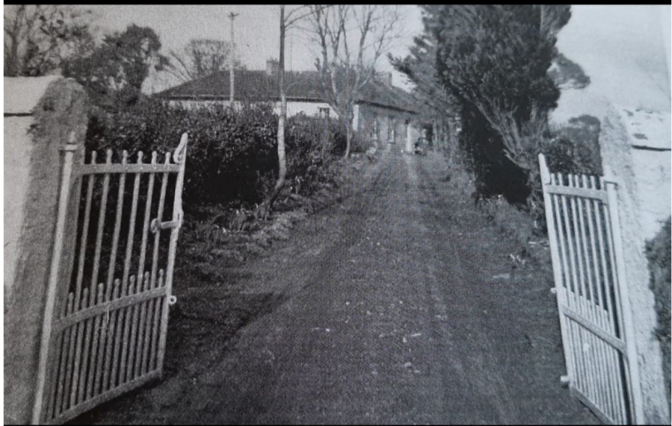
Note: no visible portico on the original structure.

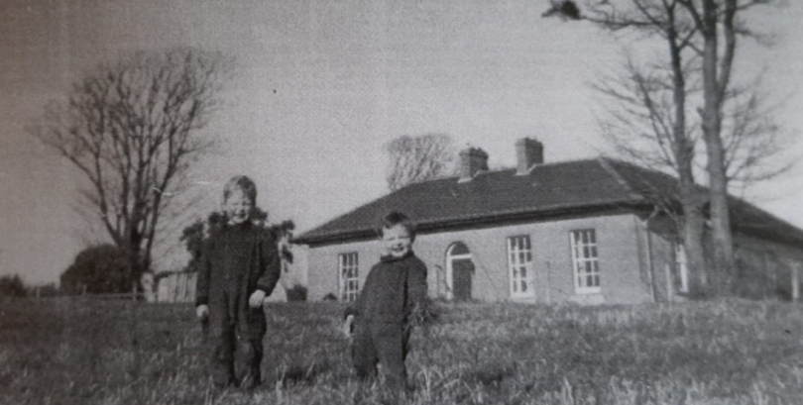

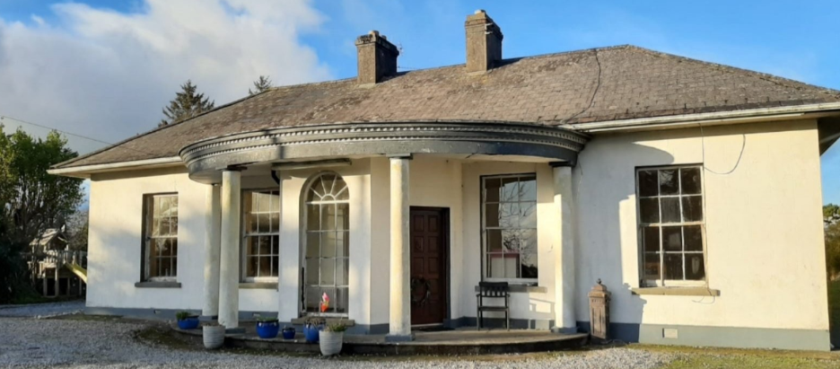
Current concrete portico entrance feature.

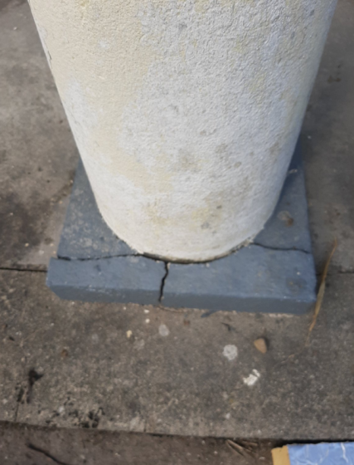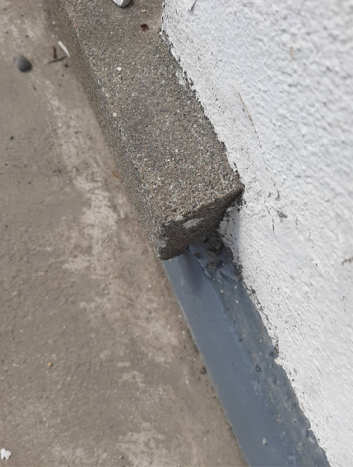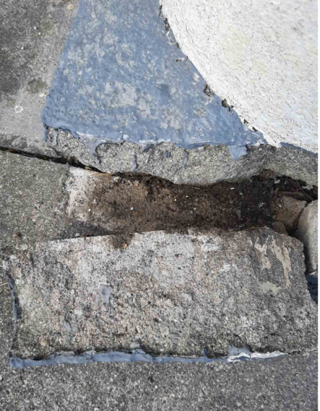
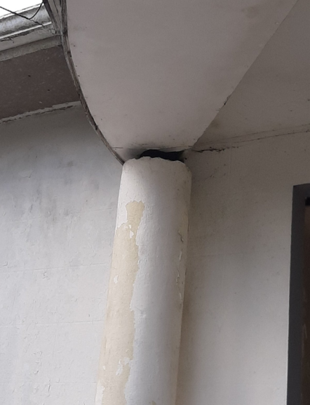
Base of concrete piers and concrete base – not cut stone.
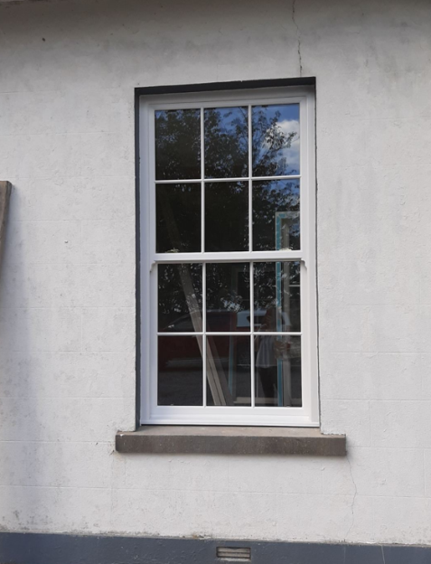
New windows on the house.

