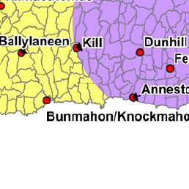

Map showing the current rural area type of the townsland Dunabrattin (outlined in blue). A vast majority is classed as a “Stronger Rural Area” with a small section marginally classed as “Areas Under Urban Pressure”.

I propose to include the areas of Dunabrattin, which are marginally in the area under urban pressure, to be included in the area type “Stronger Rural Area”

