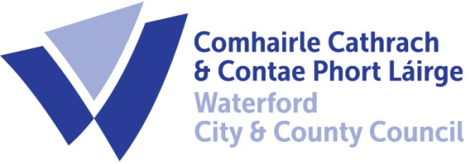

Planning Report For
Mount Congreve Lodges and
Eco-Pod Accommodation & Ancillary Works
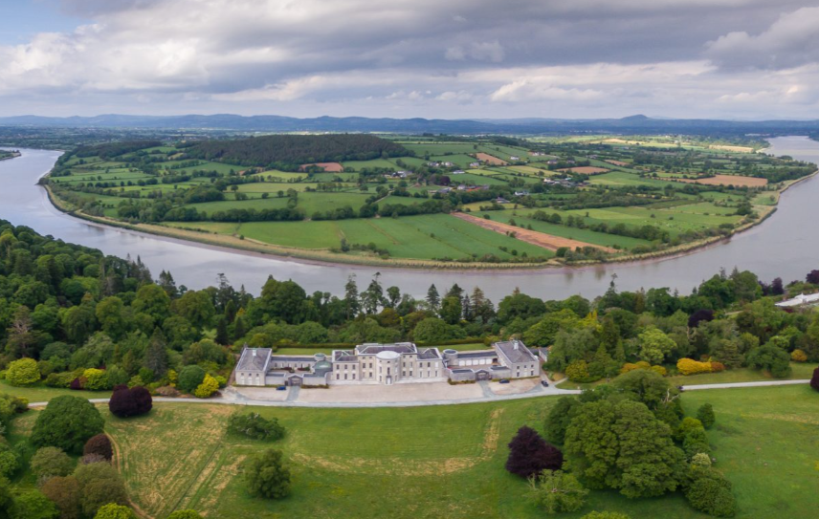

Contents
1. INTRODUCTION & Overview 1
2. Planning & Zoning 2
3. Project Scope 2
4. Proposed Works Details 3
5. Impact on Existing Estate & Gardens 3
Appendix A – Location of Pods & Infrastructure 5
Appendix B – ‘Eco-Pod’ Details 7
Appendix C – Screening Reports for Appropriate Assessment and Environment Impact 14
Appendix D – Architectural Heritage Impact Assessment 31
Appendix E – Part 8 Drawings 32

Revision No. | Prepared by | Checked | Approved | Date | Status
- | VOS | PF | - | 18/04/2024 | Final

INTRODUCTION & Overview
The redevelopment works at Mount Congreve Estate and Gardens has been ongoing since mid-2020. A total of €7.2m has now been invested with funding being provided by the Department of Rural and Community Development’s Rural Regeneration Development Fund (RRDF), Failte Ireland and ‘Matched Funding’ from Waterford City & County Council.

The works carried out to date includes the following:

- Conversion of the eastern wing/old stables of Main House into a new Visitor’s Centre incorporating a new Café & Retail Centre.
- Improved car parking facilities.
- Improvements to the walkways and pathways throughout the gardens, including surfacing, maps and signage/wayfinding.
- Creation of an Audio-Visual Tour experience.
- New Children’s playground.
- Refurbishment of the Lower Gate Lodge for accommodation.
- Construction of an ‘Integrated Constructed Wetlands’.
- Construction of a 75 space ‘Avenue Car Park’.

It is now proposed to provide additional on-site accommodation within the estate by refurbishing the other two Middle and Upper Gate Lodges and installing 5no. Eco-Type Pods within the grounds of the estate at the location shown in Figure 1.1 below and Appendix A. The lodges will accommodate up to 6 persons and the ‘Pods’ will accommodate up to 16 persons and consist of 3 x family units and 2 x smaller ones for couples. Plans for the gate lodges and further details (indicative only) of the style and type of Pods being proposed are included in Appendices B and C.

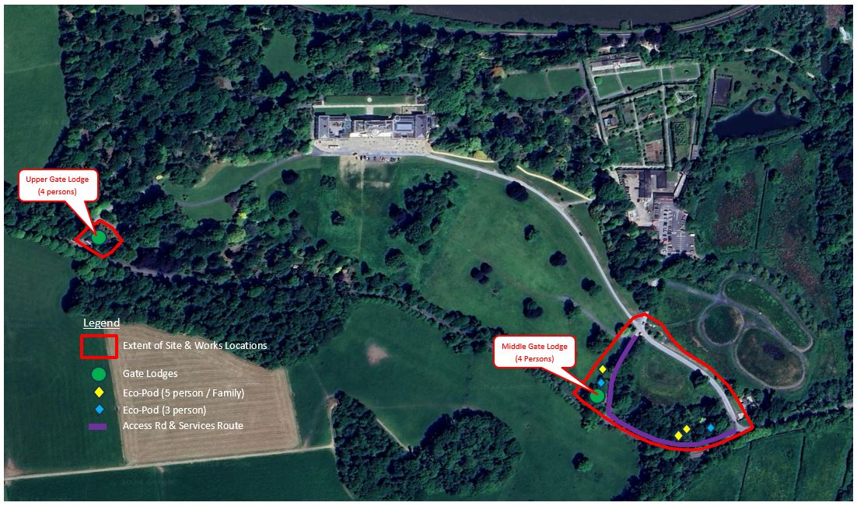

.

Fig 1.1 – Proposed locations

Planning & Zoning
The proposed development will be carried out in the townland of Mount Congreve. In the recently adopted Waterford City & Co. Co. 2022 to 2028 Development Plan, the Mount Congreve Estate and Gardens are zoned as ‘TM – Tourism’ and has been given a Specific Development Object WCD017 which states that Waterford City & Co. Co. supports ‘the sustainable development of the Mount Congreve Estate and Gardens as a major tourist asset for Waterford City and the Southeast region’.

Below is a list of policy/objective references from the Waterford City & Co. Co. 2022 to 2028 Development Plan that support and/or specifically reference the development of tourism and/or the Mount Congreve Estate itself:

Chapter 3 – Waterford City & MASP
Section 3.5 ‘Strategic Employment Locations’ includes Mount Congreve as part of a ‘diverse economic base’.

Chapter 4 – Economy, Tourism, Education and Retail
Development of tourism is included as one of the Strategic Objectives, specifically ‘to develop, deliver and promote Waterford as a year-round world class tourism destination with authentic, memorable experiences which attracts local, regional, national, and international visitors....’

Section 4.10 Sustainable Tourism – Mount Congreve is included as one of the major attractions and its continued development and upgrading as an attraction is included as part of ECON 23 i.e., Key Flagship Tourism Projects.

Chapter 11 of the Development Plan – Heritage
Section 11.10 – Historic Demesnes, Gardens & Landscapes – Specific reference is made to Mount Congreve where further commitment is given by WCCC to ‘continue to promote this tourism asset for the benefit of all’.

Project Scope
This Part 8 proposal relates to refurbishment of the gate lodges and installation of the ‘Eco-Pods’ in the locations shown in Figure 1.1. above, it also includes all necessary ancillary works such as site preparation, foul and surface & surface water drainage, potable water supply and electrical supply and data/comms connections. The approximate routes and locations and the site’s ‘Red Line Boundary’ are as shown in Figure 1.1.

The refurbishment of the Middle and Upper Gate Lodges involves a change in use from residential to short-term letting which will be covered by this Part 8.

All drawings and necessary accompanying documentation are being produced by WCCC internal resources. The specifications of the proposed Eco-Pods are included in Appendix B.

Following the opening of the new Visitor’s Centre in early November 2022, both Mount Congreve Trust and the operators of the new Café have reported that the provision of further on-site accommodation would greatly enhance the ‘visitor offering’. In addition, based on the experiences with the existing refurbished gate lodge there is ample demand to make any further on-site accommodation economically viable.

The refurbishment of the Middle and Upper Gate Lodges and the installation of the ‘Eco Pods’ will:

- Allow a further 22 persons to reside on site for short/long durations.
- Change the use of the properties from their original residential nature to short-term letting.
- Enhance the overall attractiveness of Mount Congreve.
- Be self-financing and ultimately increase the revenue/income stream to the estate and gardens.

Proposed Works Details
As mentioned above, the proposed works will involve a combination of the following:

- Refurbishment of 2 no. Gate Lodges - which will include 3 x double bedrooms providing accommodation for up to 6, refer to plans in Appendix A.
- Installation of 5 no. Eco Pods - which will include 3 x family and 2 x couple units, providing accommodation for up to 16, refer to specifications in Appendix B.
- Installation of all necessary infrastructure to serve the pods including water, wastewater, electricity and data/comms.
- All other associated ancillary works – such as landscaping, low level lighting, signage and pedestrian / walkway route improvements.

Impact on Existing Estate & Gardens
The proposed development will have no impact on the existing house and adjacent buildings and only a very minor impact on the gardens.

A Screening Report for Appropriate Assessment and Environmental Impact Assessment Screening Report have been prepared and are included in support of this planning application – refer to Appendix C for copies of both reports.

The Screening Report for Appropriate Assessment concludes that the project is not likely, alone or in-combination with other plans or projects, to have a significant effect on any European Sites.

In the Environmental Impact Assessment Screening Report, the proposed works have been assessed as a sub-threshold Environmental Impact Assessment development and concludes that an Environmental Impact Assessment is not required.

Based on the drawings/sketches produced to date, the development is being designed in compliance with the assessments and will be as sympathetic as is practical to the site locations chosen and their surroundings.

In addition to the above, the proposed works are being designed, managed and led by a Grade 1 Conservation Architect and developed in line with the ‘Historic Landscape Assessment’ report carried out by the OPW in 2022 (Mount Congreve Demesne Historic Landscape Assessment by Dr. Finola O’Kane Crimmins).

An Architectural Heritage Impact Assessment Report (AHIA) has also been prepared for the development and a copy is included in Appendix D.
Appendix E contains copies of the Part 8 Drawings in A3 format which are listed below:
- P22-026 P-101 Site Location Map
- P22-026 P-102 Overall Site Layout
- P22-026 P-103 Site Layout - Middle Lodge and Pod Area
- P22-026 P-104 Site Layout - Upper Lodge
- P22-026 P-201 Middle Lodge Existing GA
- P22-026 P-202 Middle Lodge Proposed GA
- P22-026 P-203 Upper Lodge Existing Plans
- P22-026 P-204 Upper Lodge Proposed Plans
- P22-026 P-205 Upper Lodge Existing Elevations -Sections
- P22-026 P-206 Upper Lodge Proposed Elevations -Sections
- P22-026 P-301 Proposed 2 Bed Pod -General Arrangement
- P22-026 P-302 Proposed 1 Bed Pod -General Arrangement

Appendix A – Location of Pods & Infrastructure

Location of Pods & Proposed Infrastructure – not to scale

Appendix B – ‘Eco-Pod’ Details

A – 1 Bed Type
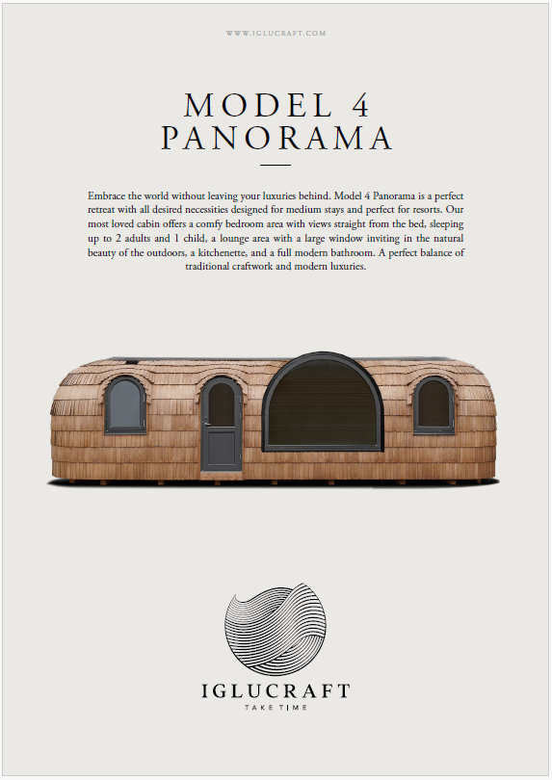

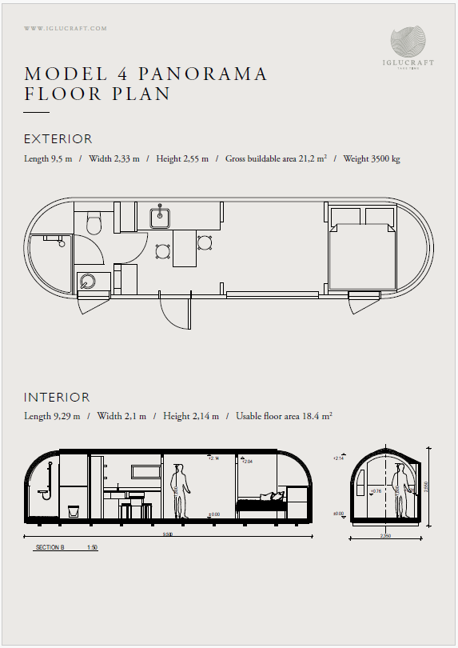

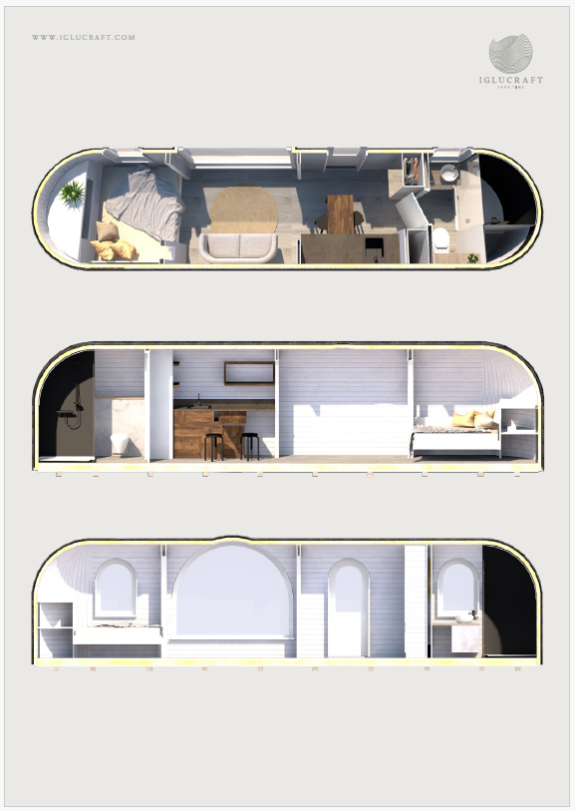

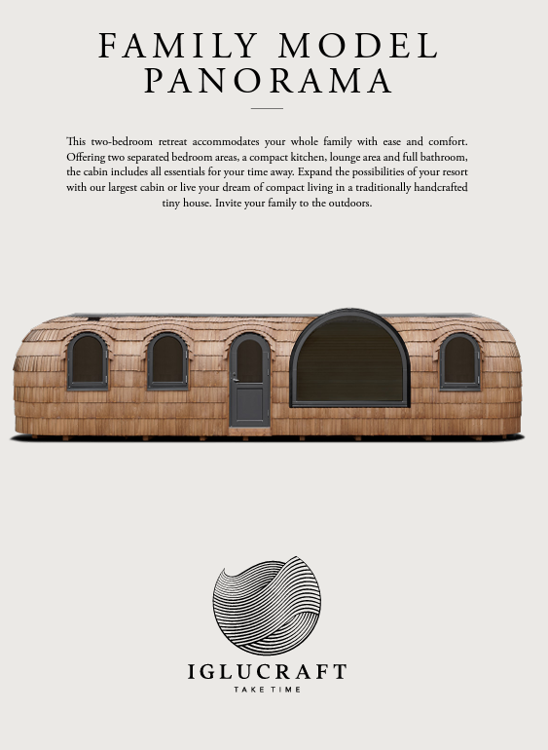
A – 2 Bed / Family Type

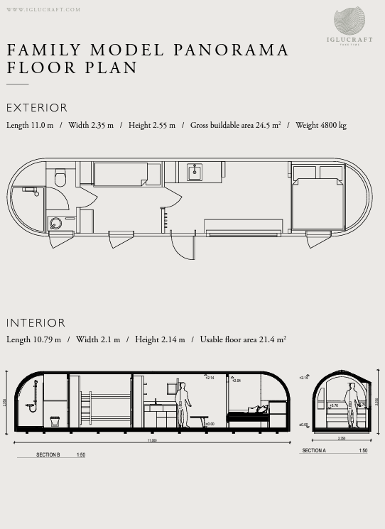

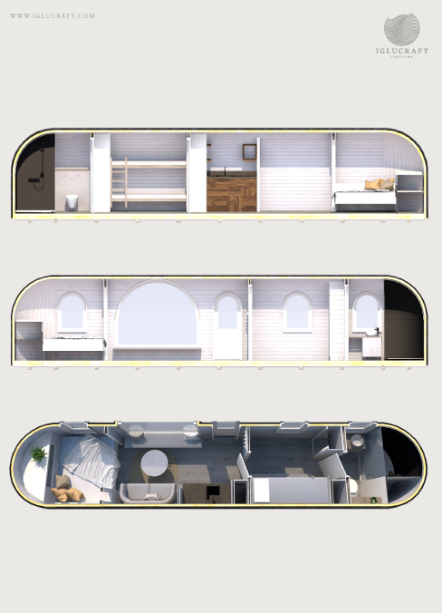

Appendix C – Screening Reports for Appropriate Assessment and Environment Impact

Habitats Directive Project Screening Assessment

Table 1: Project Details

Development Consent Type | Part 8 Local Authority Development
Development Location | Mount Congreve, Co. Waterford
File Ref

Description of the project | Development of Short Stay Accommodation at Mount Congreve  The proposed works comprise:  - The installation of 5 No. Eco-Pods that will provide onsite accommodation and be situated in lands immediately to the west of the existing entrance and avenue.  - The refurbishment of two existing Gate Lodges that are located along the western boundary of the Estate, which again will provide onsite accommodation.  - The provision of all necessary ancillary works including drainage, water supply, electrical supply, lighting, access roads, landscaping/screening to service the Eco Pods and Gate Lodges.

Table 2: Identification of Natura 2000 Sites (SACs and SPAs) which may be Impacted by the proposed development

Please answer the following five questions in order to determine whether there are any Natura 2000 sites which could potentially be impacted by the proposed development.

Impacts on SACs

1 | Impacts On Freshwater Habitats  Is the development within a Special Area of Conservation whose qualifying interests include freshwater habitats, or in the catchment of same?  Sites to consider: Blackwater River, Lower River Suir  Habitats to consider:  Rivers, Lakes and Lagoons | Yes, Mount Congreve is adjacent to but outside the boundary of the River Suir SAC. There is Hydrological connectivity to the River Suir through Ballymoat Stream.
2 | Impacts On Wetland Habitats  Is the development within a Special Area of Conservation whose qualifying interests include wetland habitats, or within 1 km of same?  Sites to consider: Comeragh Mountains  Habitats to consider:  Bogs, Fens, Marshes and Wet Heaths. | No
3 | Impacts on Intertidal and Marine Habitats  Is the development located within a Special Area of Conservation whose qualifying interests include intertidal and/or marine habitats and species, or within the catchment of same.  Sites to consider: Tramore Dunes and Backstrand, River Suir (Tidal Section), River Blackwater (Tidal Section), Waterford Estuary  Habitats to consider:  Mudflats, Sandflats, Saltmarsh, Estuary; Shingle, Reefs, Sea Cliffs. | Yes,  The River Suir Tidal Section
4 | Impacts On Woodlands , Grasslands and Dry Heaths  Is the development within a Special Area of Conservation whose qualifying habitats include woodlands or grasslands habitats, or within 200m of same.  Sites to consider: Glendine Wood Nire Valley Woods, Ardmore Head, Helvick Head  Habitats to consider:  Woodlands, Grasslands or Dunes. | No
Impacts on SPAs

5 | Impacts On Birds  Is the development within a Special Protection Area, or within 1 km of same.  Sites to consider: Tramore Backstrand, Dungarvan Bay, Blackwater Callows, Blackwater Estuary, Helvick Head –Ballyquin Coast, Mid Waterford Coast | No

Conclusion Table 2:

If the answer to all of these questions is No, significant impacts can be ruled out for Natura 2000 sites. No further assessment is required, proceed to the Habitats Directive Conclusion Statement.

If the answer to any of these questions is Yes, please refer to tables 3 and 4 below.

Table 3: Determination of Possible Impacts On Natura 2000 Sites.
Where it has been identified that there is a Natura 2000 site within the potential impact zone of the proposed development, it is necessary to try to determine the nature of the possible impacts. Please answer the following questions as appropriate.

1 | Impacts on designated freshwater habitats (rivers, lakes streams and lagoons).  Sites to consider: Blackwater River, Lower River Suir  Please answer the following if the answer to question 1 in table 2 was yes.  Does the development involve any of the following:
 | Works inside the boundary of designated site
1.1 | All works within the boundary of any SAC whose qualifying features include freshwater habitats/species, excluding small extensions/alterations to existing buildings. | No
 | Works outside the boundary of designated site
1.2 | Discharge to surface water or groundwater within the boundary of an SAC whose qualifying features include freshwater habitats/species. | No
1.3 | Abstraction from surface water or groundwater within 1km of the boundary of an SAC whose qualifying features include freshwater habitats or species. | No
1.4 | Removal of topsoil within 100m of the boundary of an SAC, whose qualifying features include freshwater habitats/species. | No
1.5 | Infilling or raising of ground levels within 100m the boundary of any SAC whose qualifying features include freshwater habitats/species. | No
1.6 | Construction of drainage ditches within 1km of the boundary of an SAC whose qualifying features include freshwater habitats/species. | No
1.7 | Installation of waste water treatment systems; percolation areas; septic tanks within 100 m of the boundary of an SAC site whose qualifying features include freshwater habitats/species. | No
1.8 | Construction within a floodplain of EU designated watercourse whose qualifying features include freshwater habitats/species. | No
1.9 | Crossing or culverting of rivers or streams within 1km of the boundary of any SAC whose qualifying features include freshwater habitats. | No
1.10 | Storage of chemicals hydrocarbons or organic wastes within 100 m of the boundary of an SAC whose qualifying features include freshwater habitats/species. | No
1.11 | Development of a large scale, within catchment of an EU designated watercourse or waterbody, which involves the production of an EIS. | No
1.12 | Development or expansion of quarries within catchment of an EU designated watercourse or waterbody. | No
1.13 | Development or expansion of windfarms within catchment of an EU designated watercourse or waterbody. | No
1.14 | Development of pumped hydro electric stations within catchment of an EU designated watercourse or waterbody. | No
2 | Impacts On Wetland Habitats  Is the development within a Special Area of Conservation whose qualifying interests include wetland habitats, or within 1 km of same?  Sites to consider: Comeragh Mountains  Habitats to consider:  Bogs, Fens, Marshes and Wet Heaths.  Please answer the following if the answer to question 2 in table 2 was yes.
 | Works inside the boundary of designated site
2.1 | All works within the boundary of an SAC whose qualifying features include heath, marsh, fen or bog, excluding small extensions/alterations to existing buildings. | No
 | Works outside the boundary of designated site
2.2 | Construction of roads or other infrastructure on peat habitats within 1km of any SAC whose qualifying features include heath, marsh, fen or bog. | No
2.3 | Development of a large scale within 1km of any SAC, whose qualifying features include heath, marsh, fen or bog, which involves the production of an EIS. | No
3 | Impacts on Intertidal and Marine Habitats  Is the development located within a Special Area of Conservation whose qualifying interests include intertidal and/or marine habitats and species, or within the catchment of same.  Sites to consider: Tramore Dunes and Backstrand, River Suir (Tidal Section), River Blackwater (Tidal Section), Waterford Estuary  Please answer the following if the answer to question 1 in table 3 was yes.
 | Works inside the boundary of designated site
3.1 | All works within the boundary of any SAC whose qualifying features include intertidal or marine habitats, excluding small extensions/alterations to existing buildings. | No
 | Works outside the boundary of designated site
3.2 | Coastal protection works within 5km of any SAC whose qualifying features include intertidal or marine habitats.
3.3 | Development of piers, slipways, marinas, pontoons or any other infrastructure within 5km of any SAC whose qualifying features include intertidal or marine habitats. | No
3.4 | Dredging within 5km of any SAC whose qualifying features include intertidal or marine habitats. | No
3.5 | Works within 1km of any SAC whose qualifying features include intertidal or marine habitats, which will result in discharges to rivers or streams directly connected to the designated site. | No
3.6 | Infilling of coastal habitats within 500m of any SAC whose qualifying features include intertidal or marine habitats. | No
3.7 | Removal of topsoil or infilling of terrestrial habitats within 100m of any SAC whose qualifying features include intertidal or marine habitats. | No
3.8 | Development of a large scale within 1km of any SAC whose qualifying features include intertidal or marine habitats, which involves the production of an EIS. | No
4 | Impacts on other designated woodlands and grasslands (woodland, upland grassland, lowland grassland, coastal grassland including dunes).  Sites to consider: Glendine Wood Nire Valley Woods, Ardmore Head, Helvick Head  Please answer the following if the answer to question 4 in table 2 was yes.  Does the development involve any of the following:
 | Works inside the boundary of designated site
4.1 | All works within the boundary of any SAC whose qualifying interests include woodland or grassland habitat types excluding small extensions/alterations to existing buildings. | No
 | Works outside the boundary of designated site
4.2 | Development within 200m of any SAC whose qualifying interests include woodland or grassland habitat types. | No
4.3 | Development of a large scale within 1km of any SAC, whose qualifying interests include woodland or grassland habitat types, which involves the production of an EIS. | No
5 | Impacts on birds in SPAs  Sites to consider: Tramore Backstrand, Dungarvan Bay, Blackwater Callows, Blackwater Estuary, Helvick Head –Ballyquin Coast, Mid Waterford Coast  Please answer the following if the answer to question 5 in table 2 was yes.  Does the development involve any of the following:
 | Works inside the boundary of designated site
5.1 | All works within the boundary of any SPA excluding small extensions/alterations to existing buildings. | No
 | Works outside the boundary of designated site
5.2 | Erection of wind turbines within 1km of any SPA. | No
5.3 | All construction works within 100m of any SPA. | No
5.4 | Infilling of coastal habitats within 500m of intertidal SPA. | No
5.5 | Works within 1km of coastal/wetland SPAs which will result in discharges to rivers or streams that are directly connected to designated sites. | No
5.6 | Development of cycleways or walking routes within 100m of SPAs. | No
5.7 | Construction works on feeding areas adjacent to SPAs | No

Conclusion Table 3: If the answer to all of the above is no or n/a, significant impacts on Natura 2000 sites can be ruled out. No further assessment is required, proceed to the Screening Conclusion Statement. If the answer to any question in table 3 is yes, you may require further information, unless you are satisfied that the project proponents have incorporated adequate mitigation into their design to avoid impacts on the Natura 2000 site (e.g. water pollution protection measures). Such information should be provided in the form of a Natura Impact Statement which should address the particular issues of concern as identified through the above.

Table 4: Consideration of Potential Impacts on Protected Species
Many of our Special Areas of Conservation are designated for species as well as for habitats. These are listed below, alongside the sites for which they are designated. Included is a short list of the types of activities which could have an impact on these species. Please tick if you are concerned that the proposed development could have an impact on these species.

Species | Relevant Sites | Activites which could have impacts on species | Possible Impacts Identified? Y/N
Otter | Lower River Suir  River Blackwater  Waterford Estuary | Activities that interfere with riverbanks. | No
Bats (all species outside designated sites) | Blackwater River, Lower River Suir, Waterford Estuary  Glendine Wood, Lismore Woods Nire Valley Woods  Along with above, in general all sites with any of the following: woods, mature treelines and hedgerows, old buildings and bridges | Activities that result in loss of woodland or hedgerow habitat or causes disturbance to roost sites. Renovations of old buildings; Re-pointing of old bridges. | Yes (Lighting at edge of treeline may affect foraging.)
Salmon | Lower River Suir  River Blackwater  Waterford Estuary | Activities that interfere with water quality, levels or the riverbed. | No
River Lamprey | Lower River Suir  River Blackwater  Waterford Estuary | Activities that interfere with water quality, levels or the riverbed. | No
Brook Lamprey | Lower River Suir  River Blackwater  Waterford Estuary | Activities that interfere with water quality, levels or the riverbed. | No
Sea Lamprey | Lower River Suir  River Blackwater  Waterford Estuary | Activities that interfere with water quality or the riverbed – estuarine areas. | No
Twaite Shad  Allis Shad | Lower River Suir  River Blackwater  Waterford Estuary | Activities that interfere with water quality or the riverbed – estuarine areas. | No
White-clawed Crayfish | Lower River Suir  River Blackwater  Waterford Estuary | Activities that interfere with water quality or the riverbed. | No
Freshwater Pearl Mussel | Lower River Suir  River Clodiagh  River Lickey  River Blackwater | Activities that interfere with water quality, levels or the riverbed; | No
Whorled Snail  Vertigo moulinsiana | River Blackwater | Activities that result in loss of fen, marsh or wet grassland habitat within or close to the SAC. | No
Killarney Fern | Glendine Wood  Lismore Woods (River Blackwater) | Woodland clearance or other activities resulting in loss or disturbance to woodland habitat within the relevant SACs. | No

Conclusion Table 4: If the answer to all of the above is no, significant impacts on species can be ruled out. If the answer to any of the above is yes, then further information is likely to be required in relation to potential for impact on that particular species. Where potential impacts on the above listed species are within designated sites, then further information should be sought in the form of a Natura Impact Statement. Where impacts are outside designated sites, then a species-specific survey should be requested.

Habitats Directive Screening Conclusion Statement

Development Type | Part 8 Local Authority Development
Development Location | Mount Congreve, Co. Waterford
Natura 2000 sites within impact zone | River Suir SAC 002137
Planning File Ref

Description of the project

The proposed works comprise:
- Construction of a new 75 space car park to the north of the existing access road which will include additional universal access spaces and electric vehicle charging points.
- Modification to the existing surfacing to the front and rear of the house.
- Provision of drainage, public lighting, landscaping/screening and all other associated ancillary works for the new car park.
Describe how the project or plan (alone or in combination) could affect Natura 2000 site(s).

No direct impacts on the qualifying interest habitats and species of the SAC. Potential for indirect impacts include lighting of previously unlit areas along treelines could impact on foraging and commuting bats. Potential for surface water run-off from the car park entering the drainage system of the Ballymoat Stream.

If there are potential negative impacts, explain whether you consider if these are likely to be significant, and if not, why not.

The proposed development is adjacent to but outside the boundary of the River Suir SAC. The proposed development will not incur loss of ecological footprint from the SAC. No Annex 1 habitats occur along this section of the River Suir. The nearest occurrence of Annex I habitats (salt marsh) is c. 14 km downstream of the Project, on the southern bank of the Suir Estuary at King’s Channel and Ballinakill. Given the distance between the project site and Annex 1 Saltmarsh there will be no reduction in the area of these habitats or any change in the distribution of these habitat types in the River Suir SAC.

The proposed car park is located approximately 180m south of the River Suir and is designed appropriate to a sustainable drainage system to avoid contaminated run-off to adjacent watercourses and the River Suir.

The lighting scheme involves luminaires with no upward light output and colour temperature of <3000 Kelvin with tones of warmer light and an appropriate dimming schedule to avoid impacts on foraging bats along the woodland edge.
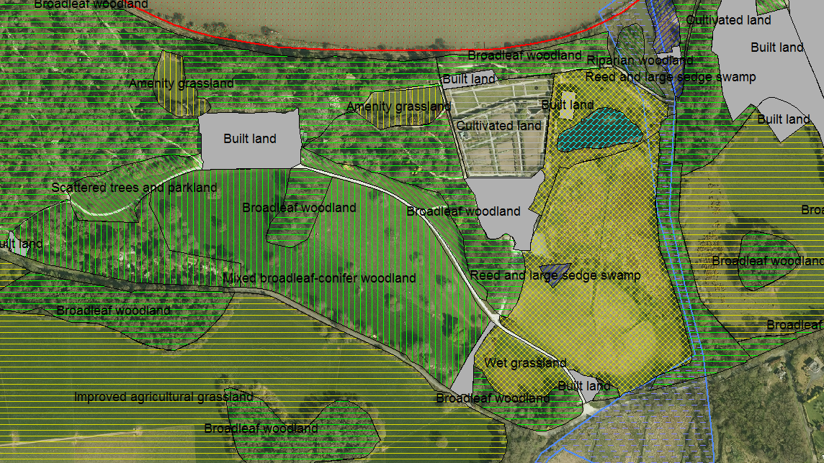
Map 1. Habitat Map of Mount Congreve Estate, Boundary of River Suir SAC runs along the riverbank to the north of the site.

Conclusion of assessment
The proposed works will take place outside the boundary of the River Suir SAC which is located to the north of the estate. Given the distance between the proposed development and the nearest qualifying interest habitat – saltmarsh occurring some 14km downstream and sustainable drainage system to deal with surface water it is considered that there will not be potential for significant effects i.e. effects that will cause loss, fragmentation, disruption or disturbance to the qualifying interest habitats and species relevant to this section and downstream on the River Suir SAC -saltmarsh habitat in the King’s Channel and Ballinakill Sections of the River Suir SAC.

Based on the foregoing, it is concluded the proposed development on its own or in combination with other projects will not pose significant effects for the conservation objectives of the qualifying interest habitats and species that occur in this section and downstream in the River Suir SAC and the proposal screens out for stage 2 Appropriate Assessment.

Environmental Impact Assessment Screening Report
1.Introduction
The EIA Directive 85/337/EEC, as amended, aims to determine the likely significant effects of a project on the environment. EIA Screening determines whether an EIA is required for a specified project. Projects requiring mandatory EIA are listed in Schedule 5 of the Planning and Development Regulations 2001, as amended. In the case of development, which is under these thresholds, planning authorities are required under Article 103 of the 2001 Regulations, (as amended) to request an EIS where it considers that the proposed development is likely to have a significant effect on the environment.
Screening involves appraisal of impacts from the proposed development according to three main criteria: -
- Characteristics of the project
- Location of proposed project
- Characteristics of potential impacts.
Schedule 6 of the Planning and Development Regulations, 2001 (as amended), outlines the aspects of the environment likely to be significantly affected by a proposed development. These are: human beings, flora and fauna, soil and geology, water, air& climate, landscape, material assets, cultural heritage and the inter-relationships between the range of environmental criteria.

The proposed works at Mount Congreve Estate comprise:
- Refurbishment of two Gate Lodges, Middle and Upper, for accommodation purposes.
- Installation of 5no. Eco-Pods for accommodation purposes.
- Provision of foul & surface drainage, potable water, electrical supply, lighting, data/comms connections, landscaping/screening and all other associated ancillary works.
2. Screening Assessment

Table 1. Characteristics of proposed development
Is the size and design of the proposed works significant? | The gate lodges are situated to the west of the existing entrance and avenue. The pods are proposed to be installed in an area of approximately 3.5 acres immediately to the west and adjacent the existing main entrance. The works are contained within surrounding lands adjacent to Mount Congreve House and have been guided by an understanding of the heritage significance of the house and its landscape.
Potential for impacts from project in cumulation with other existing and/or approved projects | The development of Mount Congreve as an enhanced visitor attraction will attract increased visitor numbers in the range of 100,00-150,00 per annum with a maximum of 3,000 visitors per day at peak season. An integrated constructed wetland effluent treatment system to serve the increased visitor numbers was completed in 2022. A visitors car park providing 75 spaces was completed in early 2024. The Waterford Greenway runs to the north of Mount Congreve Gardens.  The provision of on-site accommodation for visitors is seen as an essential component in enhancing the gardens as an attraction.
Use of natural resources in particular land, soil, water and biodiversity? | New land take is required for the proposed Eco-Pods. The area subject to development comprises existing amenity grassland and broadleaf woodland adjacent the main entrance.
Will the works produce waste? | Construction works will produce waste which will be removed from site on completion of works.
Will the works create a significant amount of pollution or nuisance? | Best construction practice as guided by an Environmental Method Statement will ensure avoidance of any risk of pollution from construction works. The site is self-contained and away from other private residences minimising impacts on private residential amenity.
Risk of major accidents and/or disasters relevant to the project including those caused by Climate Change in accordance with scientific knowledge? | The scale of the work is such that there is negligible risk of a major accident and /or disaster including those caused by climate change.  No works are proposed for the area in the eastern part of the site which is a known flood risk area.
Risks to human health (water contamination, air pollution) | Best construction practice as guided by an Environmental Method Statement will ensure avoidance of any risk of pollution from construction works.  This area of Waterford enjoys good air quality and while increased visitor numbers will increase level of traffic emissions the level of such should not change the overall air quality classification for the locality.

Table 2. Location of Proposed Development
Environmental Sensitivity of project in relation to existing and approved land use. | Mount Congreve County House is a Protected Structure rated of national importance and within an area classed as a sensitive landscape in the Waterford County Development Plan Scenic Landscape Evaluation.  Screening of the lodges and Eco-Pods involves the established Mount Congreve practice of layered ornamental planting with dense infill understorey, particularly around the Eco-Pods so that they are not evident upon approach.  The historic demesne is located beside the River Suir SAC. The proposed development will not incur loss of ecological footprint from the SAC. No Annex 1 habitats occur along this section of the River Suir. Under the Water Framework Directive water quality in the Mid-Section of the River Suir- is classified as having poor status.
Relative abundance, availability, quality and regenerative capacity of natural resources (including soil, land, water and biodiversity) in the area and its underground. | New land take will be required for the Eco-Pods and will incorporate a surface design appropriate for a sustainable drainage system. No works are proposed for the area in the eastern part of the site which is a known flood risk area.
Absorption capacity of the natural environment including wetlands, riparian areas, river mouths, coastal zones and the marine environment, mountain and forest area. | The design process for the provision of additional accommodation at Mount Congreve has been guided by an understanding of the heritage significance of the House and its Landscape regarding the content and recommendations of the Historic Landscape Assessment (the O’Kane Report) commissioned by the OPW in 2022.
Potential of works to impact directly or indirectly on sites designated for nature conservation (NHA/SAC/SPA) | An AA Screening was carried out and concluded no potential for significant effects on the conservation objectives for the qualifying interest habitats and species of the River Suir SAC.
Potential for impacts directly or indirectly on Habitats or Species listed on Annex I, II and IV of the Habitats Directive | Otters are known to occur widely in the River Suir. However, the scale and location of the proposed works will not interfere with any breeding or resting area for this species.  Freshwater Pearl Mussel and White-clawed Crayfish do not occur within this section of the River Suir and thus the project will not pose significant effects on the Conservation Objectives for these qualifying interests.  Lamprey species, Twaite Shad and Atlantic Salmon are known to migrate through the Middle Suir during their migrations. All these species are sensitive to water quality impacts.  No Annex 1 habitats occur along this section of the River Suir. The nearest occurrence of Annex I habitats (salt marsh) is c. 14 km downstream of the Project, on the southern bank of the Suir Estuary at King’s Channel and Ballinakill.  The woodland demesne of Mount Congreve is an important habitat for bats providing rich foraging grounds.
Potential for impacts on breeding places of any species protected under the Wildlife Act? | The woodland demesne of Mount Congreve is an important habitat for bats providing rich foraging grounds. The lighting scheme will involve luminaires with no upward light output and colour temperature of <3000 Kelvin with tones of warmer light and an appropriate dimming schedule to avoid impacts on foraging bats along the woodland edge.
Potential to impact directly or indirectly on any listed ACA in the County Development Plan? | Mount Congreve is a protected structure including the house and curtilage of associated out buildings.
Potential to impact directly or indirectly on any protected structure or recorded monuments and places of Archaeological Interest | Mount Congreve is a protected structure rated of national importance and the proposed works are informed and designed in accordance with the findings of an Architectural Heritage Impact Assessment supporting the Part 8 application.
Potential to impact directly or indirectly on listed or scenic views or protected landscape in the County Development Plan? | Mount Congreve Demesne is designated as a sensitive landscape and the river corridor along the Suir is classed as Visually Vulnerable. The existing vista from the River Corridor will not be impacted as it faces on to a vegetated buffer and the walled garden. The majority of works are contained within existing amenity grassland and broadleaf woodland. The proposed works shall be designed in sympathy with the demesne landscape involving screening by tree planting.
Potential to impact on areas in which there has already been a failure to meet the environmental quality standards and relevant to the project, or in which it is considered that there is such a failure. | Under the Water Framework Directive water quality in the Mid-Section of the River Suir- is classified as having poor status. New land take will be required for car park and will incorporate a surface design appropriate for a sustainable drainage system. No works are proposed for the area in the eastern part of the site which is a known flood risk area.
Potential to impact on densely populated areas. | The project will complement the Waterford Greenway in terms of tourism offering and visitor attractions in the Waterford area and will increase level of visitor use to the area from existing levels to projected numbers of 100-200,000 per annum. It will also enhance the site as public amenity resource to residents of Waterford City (50,000) and the wider county (80,000).

Table 3. Characteristics of Potential Impacts
Human Beings | The proposed project will confer positive benefits on human beings providing benefits for recreation and quality of life and enhanced access to the historic demesne and woodland gardens. The development will allow appreciation of the natural and built environment providing access to the historic house and landscape within easy reach of Waterford City.
Flora and Fauna | The area subject to development comprises existing amenity grassland at the edge of broadleaf woodland. AA Screening concluded no potential for significant effects on the SAC.
Soils and Geology | No sites of geological heritage will be impacted. The site consists of sandstone till soils.
Water | Mount Congreve is bounded by 3 rivers- Whelanbridge to the West, Ballymoat Stream to the East and the River Suir to the north. Water quality in the Mid-Section of the River Suir is rated as poor. New land take will be required and will incorporate a surface design appropriate for a sustainable drainage system. No works are proposed for the area in the eastern part of the site which is a known flood risk area.
Air & Climate | Increased visitor numbers to Mount Congreve majority of which will be by private car and bus will give rise to increased traffic emissions along the N25 and local approach road. The level of such should not change the overall air quality classification for the locality.
Noise & Vibration | There will be temporary disturbance during installation works. The site is self-contained and away from other private residences.
Landscape | Mount Congreve Demesne is rated of national importance for its historic house and gardens. The proposed accommodation is designed in sympathy with the demesne landscape involving screening by tree planting reducing the overall impact of the Eco-Pods.
Material Assets | The proposed development will confer positive benefits to the county’s tourism offering providing enhanced access to a historic house and landscape complementing existing recreational assets such as the Waterford Greenway, Curraghmore House Waterford Suir Valley Railway and Copper Coast Geopark.
Cultural Heritage | The Mount Congreve Estate is a nationally important historic park and garden. Set in extensive landscaped grounds, the impressive palatial country house forms an important element of the architectural heritage of County Waterford and a landmark in the locality, most notably from the vantage point of the River Suir to the north. The re -development of the house and gardens seeks to ensure its sustainability by enhancing the house and grounds as a visitor attraction providing revenue to maintain the historic site.
Interaction of Foregoing | The proposed development shall respect the heritage qualities of the demesne and conserve the integrity and setting of the heritage buildings and surrounding natural environment.

Table 4. Discussion of Potential Impacts
Will a large geographical area be impacted because of the proposed works? | New land take will be required for the Eco-pods.
Will a large population be impacted because of the proposed works? | No, works are contained within the site buffered from local residences and the Greenway by the surrounding woods and demesne landscape.
Are any trans-frontier impacts likely to arise from proposed works? | Water quality in the River Suir which borders County Kilkenny will be subject to regular monitoring under the River Basin Management Plan.
Is the intensity and complexity of impacts associated with the proposed works considered significant? | No, an Architectural Heritage Impact Assessment has informed best conservation practice.
Is there a high probability that the impacts will occur? | Impacts are not considered significant and will ensure the sustainability of the historic house and gardens for the protected structure and historic landscape.
What is the expected onset, duration, frequency and reversibility of the impact? | The works are scheduled for 2024 and designed to be a permanent intervention in the landscape.
Cumulation of the impact with the impact of other existing and/or approved projects? | The proposed development will complement the amenity offering to walkers and cyclists who use the Waterford Greenway and visitors to Curraghmore, Copper Coast Geopark and the Waterford Suir Valley Railway.
Will it be difficult to avoid, or reduce or repair or compensate for the effects? | No significant impacts anticipated. An Architectural Heritage Impact Assessment has informed best practice for interventions in the protected structure and historic landscape.

3. Conclusion
In consideration of the above including scale and design of the proposed development and having appraised the characteristics and location of the proposed development which has been informed by an Architectural Heritage Impact Assessment and appraisal of the characteristics of potential impacts it is concluded that an EIAR is not required for the proposed development.

Appendix D – Architectural Heritage Impact Assessment

Appendix E – Part 8 Drawings

