Comhairle Cathrach & Contae Phort Láirge
Waterford City and County Council

Development under section 179 of the Planning and Development Act, 2000, as amended, and Notice pursuant to the requirements of Part 8, Article 81 and Article 120(3) of the Planning and Development Regulations 2001, as amended

Proposed Development of a Multi-Use Games Area (MUGA) and associated site works and services at Ringnasilloge, Dungarvan, Co. Waterford
In accordance with Part 8, Article 81, of the above Regulations, notice is hereby given that Waterford City and County Council proposes to carry out a development at Ringnasilloge, Dungarvan, Co. Waterford.
The development will consist of:
• The construction of a Multi-Use Games Area (MUGA) to include associated drainage, lighting, fencing
and civil works. The proposal includes preparation and provision of pitch area, boundary treatments and
all other associated site development works and services at Ringnasilloge, Dungarvan, Co. Waterford
Plans and particulars of the proposed development will be available for inspection at Waterford City & County Council, Customer Care Desk, Civic Offices, Dungarvan, County Waterford between the hours of 9:30am to 4:00pm Monday to Friday for the period 17th May – 20th of June 2024 inclusive (excluding Bank and Public Holidays).
Plans and particulars of the proposed development will also be available for viewing on our online consultation portal at http://waterfordcouncil.ie/projects/public-consultations/index.htm from 17th May to 20th June 2024.
The proposed development has undergone Appropriate Assessment Screening under the Habitats Directive (92/43/EEC) and the Planning and Development Act 2000 as amended, and the Planning Authority has determined that a Stage 2 Appropriate Assessment is not required in this instance.
In addition, the proposal has undergone screening for Environmental Impact Assessment under the EIA Directive 2014/52/EU (and the relevant provisions of the Planning and Development Act, as amended), and the Planning Authority has determined that there will be no likelihood of significant effects on the environment arising from the proposed development and, therefore, an Environmental Impact Assessment is not required. In accordance with Article 120 (3) of the Planning & Development Regulations (as amended), any person may, within 4 weeks from the date of this notice, apply to An Bord Pleanála for a screening determination as to whether the proposed development would be likely to have significant effects on the environment.
Submissions or observations with respect to the proposed development, dealing with the proper planning and sustainable development of the area, can be made in writing to:
• Director of Housing, Community and Emergency Services, Waterford City & County Council, City Hall The Mall, Waterford
• or by emailing ▪ consult@waterfordcouncil.ie on or before 2pm on 8th of July 2024,
and should be clearly marked Development of MUGA at Ringnasilloge.
All comments, including names of those making comments, submitted to the Council in regard of this scheme will form part of the statutorily required report to be presented at a meeting of the elected members. Accordingly, they will also be included in the minutes of that meeting and may appear in the public domain.
Waterford City & County Council is subject to the provisions of Freedom of Information (FOI Acts 1997 and 2014) and the Data Protection Acts 1988 and 2013.
Mr. Ivan Grimes, Director of Housing, Community & Emergency Services,
Waterford City & County Council,
City Hall, The Mall, Waterford. Date: May 17th, 2024

Documents
- Newspaper Advert
- Part 8 Report
- Site Notice
- AA Screening
- EIA Screening
- Floor Risk Assessment
- Site Location Map
- Dungarvan MUGA layout map

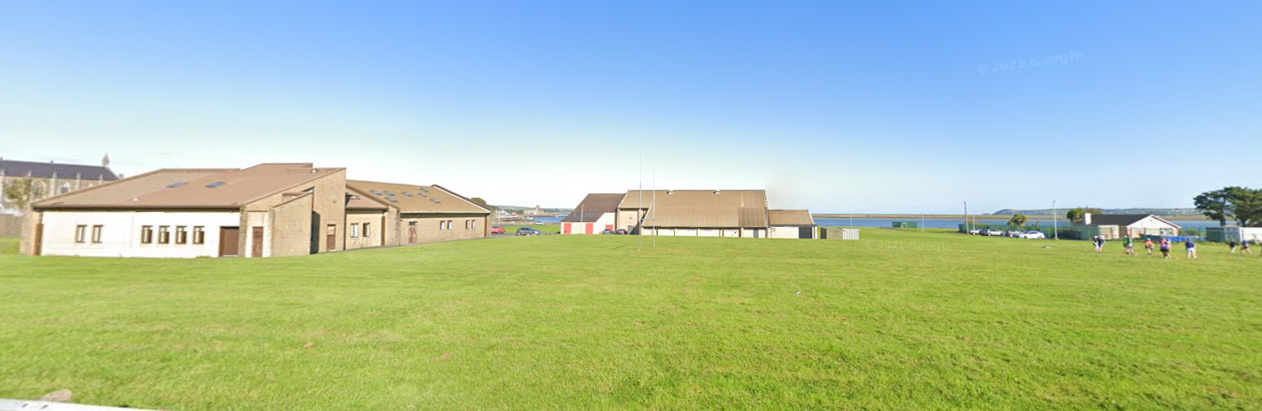
PLANNING REPORT FOR THE DEVELOPMENT OF
MULTI-USE GAMES AREA (MUGA) AT RINGNASILLOGE, DUNGARVAN
MAY 2024

Contents
1. INTRODUCTION....................................................................................................... 3
2. DESCRIPTION OF THE PROPOSED WORKS – CONSULTATION ..................................3
3. SUMMARY OF THE PROPOSED DEVELOPMENT ......................................................3
4. LOCATION.................................................................................................................4
5. STRATEGIC JUSTIFICTION FOR THE PROJECT.............................................................4
6. ENVIRONMENTAL ASSESSMENT ..............................................................................5
7. IMPACT OF THE SCHEME .........................................................................................5
8. CONCLUSION............................................................................................................6
APPENDIX 1 – AA Screening………………………………………………………………………………….….7
APPENDIX 2 - EIA Screening………………………………………………………………………………………8
APPENDIX 3 – Flood Risk Assessment……………………………………………………………………….9
APPENDIX 4 - Project Drawings…………………………………………………………………………………10

- Introduction
This report relates to the development of a Multi-Use Games Area (MUGA) at Ringnasilloge, Dungarvan. The proposed MUGA is to measure 30m x 50m in area and is to be located in the grassed area behind Dungarvan Sports Centre. It is hoped that the MUGA will enable local sports enthusiasts to enjoy a variety of sports on an all-weather surface. It is proposed that the MUGA will be fenced and will have appropriate high-level lighting.
The purpose of this report is to describe the proposed development. Together with the planning drawings and a screening for Appropriate Assessment and Environmental Impact Assessment, it forms the planning documentation for the project.

- Proposed Works – Consultation
The notice of the Part 8 planning procedure for the proposed works at Ringnasilloge, Dungarvan is to be advertised in the Dungarvan Observer (local newspaper) on the week ending Friday May 17th 2024. The plans and particulars relating to the proposed works will be placed on public display between Friday, May 17th and Thursday, June 20th, 2024.
Plans and particulars of the proposed development will be available for inspection or purchase, at the Civic Offices, in Dungarvan between the hours of 9:30am and 4:00pm Monday to Friday for a four week period (excluding Bank and public holidays).
A copy of the plans and particulars are also available to view online, on the Waterford City and County Council website at http://waterfordcouncil.ie/projects/public-consultations/index.htm
Submissions or observations can be made with respect to the development on or before 2pm on the 8th July 2024, either in writing or via an online submission form. Notice was given to prescribed bodes in accordance with Article 81 of Part 8 of the Planning and Development Regulations 2001 (as amended).

- Summary of the Proposed Development
The nature and extent of the proposed works, as described in the public and site notice, is as follows: Construction of a 1500m² Multi-Use Games Area extending to 50m in length and 30m in width, located in the grassed area behind Dungarvan Sports Centre, and beside Dungarvan Youth and Community Centre, in the townland of Ringnasilloge. The surface will be of a multi-purpose material (eg astroturf or tarmacadam or similar) and will be suitable for use in a variety of sports.
It is proposed to include the following ancillary infrastructure: ▪ 2.5m high mesh fencing around the facility with 2.5m high ball-stop netting and a single gate for access ▪ 4 column floodlighting system ▪ 2m wide walking/running track surround ▪ Surface lining to accommodate a variety of sports ▪ Basketball hoops, nets and goals as required ▪ Car and bicycle parking zones.
The proposed lighting is to be designed by a suitably qualified lighting specialist so that there will be no light spillage or glare and the lighting is to be directed so as to minimise the light spillage outside the boundaries of the site. It is also intended that the lighting will be extinguished during night-time hours. Set usage times will be agreed and imposed. The proposed screen planting will also mitigate light spillage and reduce the visual impact of the development when viewed from the west.

- Location
The proposed MUGA is to be located in the grassed area behind Dungarvan Sports centre, in the townland of Ringnasilloge, in an area already being used as an unofficial sports pitch.

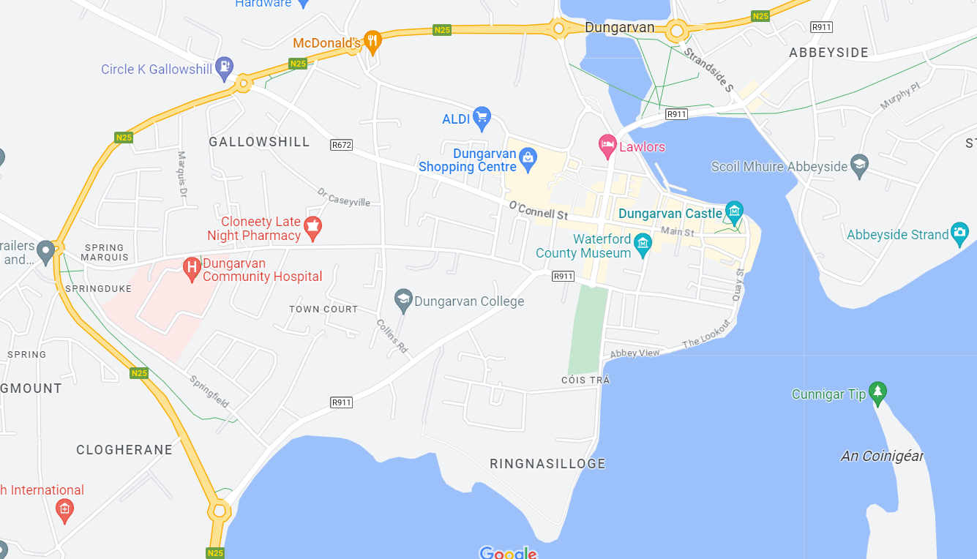
Proposed location

- Justification for the Project
Dungarvan is an active town that offers a large variety of sports to its inhabitants of all ages. Currently, there is no local all-weather facility for use by the general public. Community groups are finding it increasingly difficult to find suitable areas to train, play and compete, both formally and informally, in the locality. Dungarvan Sports Centre is used by many community groups as well as local schools for physical education and sports days. The addition of a MUGA alongside the Sports Centre and the Youth and Community Centre would be very welcome. The proposed location is easily accessed from the town centre and is a short walk from three local secondary schools and two local primary schools. The provision of a walking/running track around the MUGA would accommodate the town’s large walking and running community as well as many keep-fit, couch to 5k, operation transformation and other recreational walking groups.

- Environmental Assessment
The proposed works are located behind Dungarvan Sports Centre in a grassed area regularly used for informal football matches and other recreational activities.
In the Waterford City and County Development Plan 2022-2028, the area is zoned Open Space and Recreation with a stated objective to preserve and provide for open space and recreational amenities which includes community facilities and playing fields. This project aims to utilise some of the existing open space to provide for a community playing facility and so falls within the allowed provisions of the plan. Access to the remaining existing open space will not be altered.
In relation to flood risk analysis, the site is located outside of Flood Zones A and B. Less than one third of the site is located within the Office of Public Works (OPW) High end future scenario 1/1000 flood zone, identified in their National Coastal Flood Hazard Maps. It is anticipated that the facility would be closed during severe weather events (1/1000 flood scenario). A Flood Risk Assessment was carried out and concluded that the overall risk of flooding posed by this proposed development is negligible and will not result in alterations to existing drainage paths. See report in Appendix 3
The proposed development has undergone Appropriate Assessment Screening under the Habitats Directive (92/43/EEC) and the Planning and Development Act 2000 as amended, and the Planning Authority has determined that a Stage 2 Appropriate Assessment is not required in this instance. See report in Appendix 1.
In addition, the proposal has also undergone screening for Environmental Impact Assessment under the EIA Directive 2014/52/EU (and the relevant provisions of the Planning and Development Act, as amended), and the Planning Authority has determined that there will be no likelihood of significant effects on the environment arising from the proposed development and, therefore, an Environmental Impact Assessment is not required. See report at Appendix 2.
In accordance with Article 120 (3) of the Planning & Development Regulations (as amended), any person may, within 4 weeks from the date of this notice, apply to An Bord Pleanála for a screening determination as to whether the proposed development would be likely to have significant effects on the environment.
7. Impact of the scheme
This project will provide an enhanced sporting offering for the local community and the wider town of Dungarvan. It will increase sport options for the general public and give people the opportunity to try out a variety of sports. Local schools will benefit from the availability of an all-weather playing surface as it will enable physical education in the form of outdoor football, volleyball, hockey and basketball at a walkable commute from their schools. It is planned to light the proposed MUGA. The lighting is to be designed so that light spillage and/or glare is not an issue for neighbouring properties. Additional parking, including bicycle parking, is to be provided in the vicinity of the project site as outlined on the project drawings. The MUGA is strategically located behind Dungarvan Sports Centre and beside Dungarvan Youth and Community Centre and will add to the positive civic and community ambiance of the area.

- Conclusion
The proposed development will support and complies with the policies and objectives of the current Waterford City and County Development Plan 2022-2028 and complies with ministerial guidelines, government policies and with the Regional Planning Guidelines.

Appendix 1
AA Screening Assessment

Appendix 2
EIA Screening Assessment

Appendix 3
Flood Risk Assessment

