Alterations to existing Railway Station
and
Construction of three single storey buildings
for
Short stay accommodation and exhibition space
at
Kilmacthomas, Co. Waterford.

(Protected Structure, Waterford RPS WA750624)

Part 8 Report
March 2024

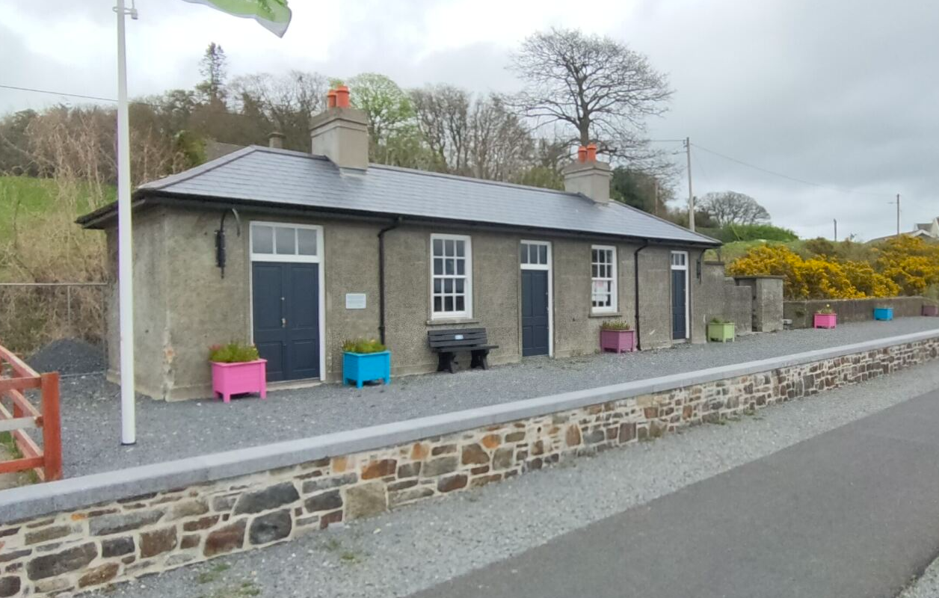

Contents

Overview 2
1. Scheme Proposal 3
2. Development Policy 4
3. Development Assessment 5
3.1 Site Location 5
3.1.1 Public Transport 5
3.1.2 Education 5
3.1.3 Health 5
3.1.4 Sports and Amenities 5
3.1.5 Commercial Enterprise 5
4. Site Appraisal 6
4.1 Site Location 6
4.2 Planning & Zoning 6
4.3 Services & Accessibility 7
4.3.1 Potable Water 7
4.3.2 Foul Water & Storm Water 7
4.3.3 Flood Risk 8
4.3.4 Vehicular Access 8
4.3.6 Protected Structures and Archaeology 9
4.5 Environmental Impact 9
4.6 Site Constraints and Abnormalities 10
Appendix A – Environmental Screening Reports 12
Appendix B – List of Drawings 41

Overview
The proposed development consists of the provision of short stay accommodation. The existing Railway Station, a protected structure, will become a two-bed property with minor internal alterations. Three additional buildings will be constructed consisting of:

- Construction of two “Line Huts” each providing single room accommodation.
- Construction of a single storey exhibition space.
- Designated parking for guests, to include secure bicycle parking.

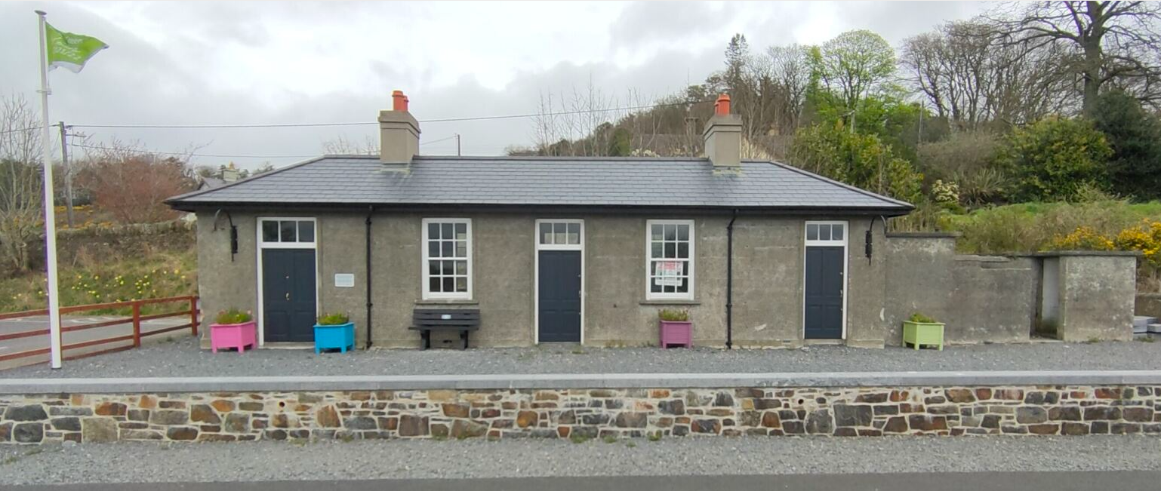
Fig 1.1 – Existing Site.

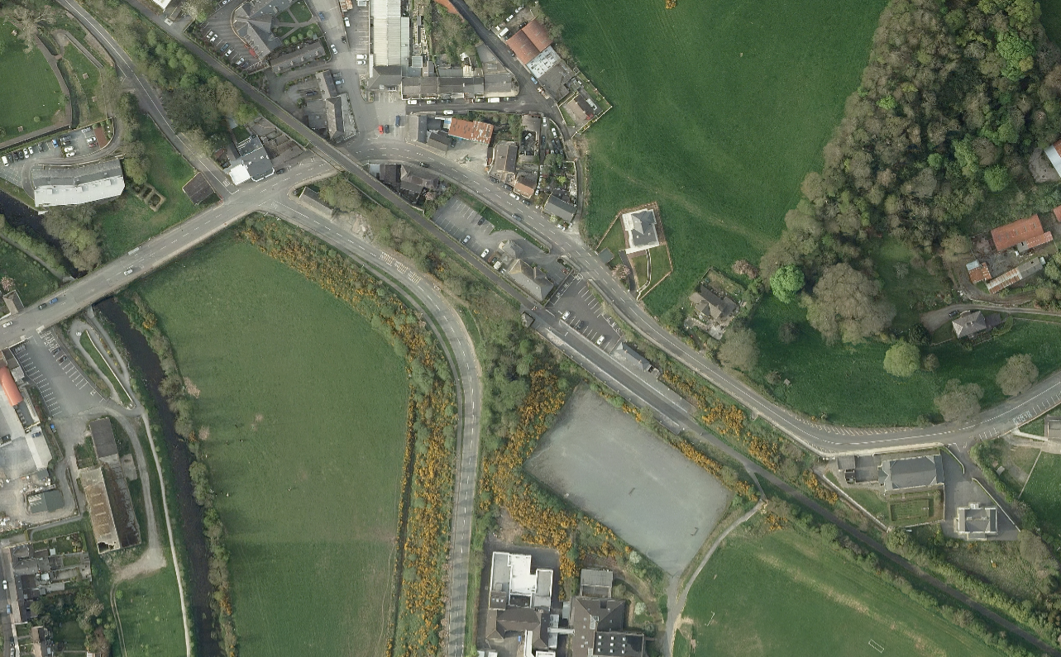

Fig 1.2 - Aerial image of Site Location indicated in red.

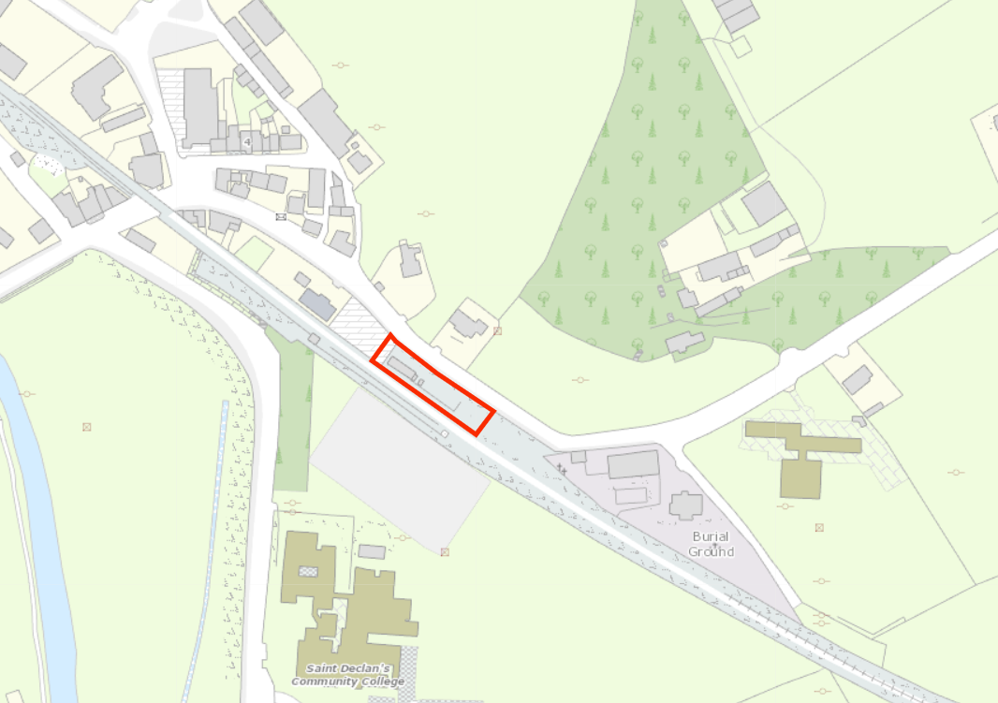

Fig 1.3 – OSI Map of Site Location and Red Line Boundary.
The same red-line boundary as above is shown on all subsequent maps and plans within this Report, for consistency purposes, and reference, etc. See selection of proposed plans in appendix of this Pre-Part 8 Report for a general over-view of proposed works.

Scheme Proposal

The existing Railway Station while re-roofed in recent years remains unused. This scheme will revitalise the historic train station and provide tourist accommodation adjacent to the ever-popular Waterford to Dungarvan greenway.

The scheme has incorporated the following design elements.

- Minimal internal intervention in the renovation of the Railway Station, the external envelope of the building will remain as it is.
- External walls of the Line Huts and exhibition space will be in corrugated metal In keeping with the traditional style of the Railway Station.
- The viewing window to the exhibition space is under a covered area and remains open at all times.

Development Policy
Within the current WCCC Plan 2022‐2028, the buildings within the site are zoned as follows:
- Kilmacthomas Settlement Boundary, WCCC Development Plan 2022 - 2028
- GZT Zone Category: RV - Rural Village - Protect and promote the character of the Rural Village and promote a vibrant community appropriate to available physical and community infrastructure. WCCC Development Plan 2022 - 2028
The proposal addresses a ‘Specific Development objective’ in Volume 3, Appendix No. 2 of the WCCC Development Plan 2022 – 2028 as follows:

- KMDO6/DO6 It is an objective of the Council to protect the elements of the streetscape of architectural or historical value, by the retention of the vernacular houses such as those on those on St Anne’s Terrace and on Main Street. Other features worthy of retention are rubblestone walls, freestanding water pumps, and elements of the former railway line including the Railway Station, post boxes and pillar boxes as identified the on NIAH survey

The proposal also addresses Sustainable Tourism as identified in WCCC Development Plan 2022 – 2028, Tourism Policy Objective:
- ECON 23, Development of sites of interest along the existing Waterford Greenway e.g. Woodstown Viking Site, Train Station in Kilmacthomas
- ECON24 Tourism Accommodation
The proposal adds to the user facilities available in Kilmacthomas

- Project Ireland 2040 identifies infill and regeneration opportunities as a key growth enabler.
- National Policy Objective 5 of the NPF states that the development of cities and towns of sufficient scale and quality to compete internationally will be the drivers of national and regional growth, investment, and prosperity.
- National Policy Objective 11 of the NPF outlines that in meeting urban development requirements, there will be a presumption in favour of development that can encourage more people and generate more jobs and activity within existing cities, towns and villages, subject to development meeting appropriate planning standards and achieving targeted growth.
- The Development Plan KMDO6/DO6 It is an objective of the Council to protect the elements of the streetscape of architectural or historical value, by the retention of the vernacular houses such as those on those on St Anne’s Terrace and on Main Street. Other features worthy of retention are rubblestone walls, freestanding water pumps, and elements of the former railway line including the Railway Station, post boxes and pillar boxes as identified the on NIAH survey

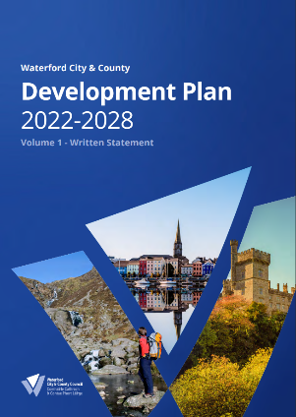
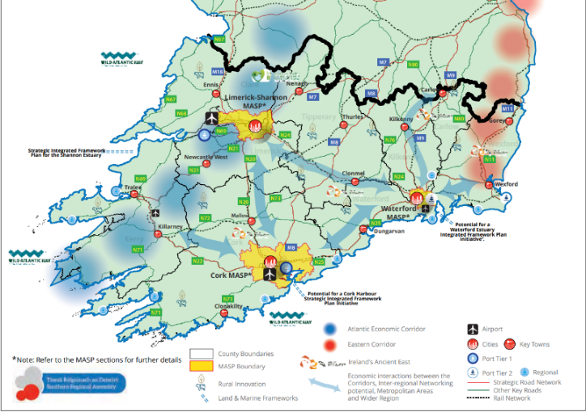

Fig 2.1 - RSES Strategy Map and WCCC Development Plan 2022-2028

Development Assessment

3.1 Site Location
The Part 8 development is located within the Comeragh Area of Waterford County. The site and existing building arrangement align with the former Kilmacthomas railway line, now the popular Waterford to Dungarvan greenway. The property is accessed from the Greenway carpark off the Rossmore Road.

3.1.1 Public Transport
The proposed development is located circa 250m from the Kilmacthomas bus stop, with two bus routes 362 & 366 connecting to Waterford Bus Eireann station serving local, regional and national routes. With an onward connection to Plunkett Train station (<1km) with Intercity train services connecting the city to Rosslare Port, Dublin and Limerick provides an expanding schedule. Taxi services are available from the Tramore Terminus. The development is on the Waterford to Dungarvan Greenway that connects to Waterford’s South Quays and the new sustainable transport bridge crossing the River Suir which is currently under construction.

3.1.2 Education
The closest schools to the proposed development are as follows:
- St. Declan's Community College
- Kilmacthomas Primary School
- Naionra Choill Mhic Thomaisin, NS
- Kilmacthomas Montessori
There are a number of crèches located in the Kilmacthomas area.

3.1.3 Health
University Hospital Waterford is located approximately 28km from the site.
UPMC Whitfield Private Clinic is located approximately 28km from the site.
There are a number of medical practices in the Kilmacthomas area.

3.1.4 Sports and Amenities
The Kilmacthomas GAA club is located approx. 1km south of the proposed development, and Kilmacthomas AFC is approx. 1.5km away. Waterford Greenway, Kilmacthomas Bike Hire & Cycle Tours, is located 350 m from the site.

3.1.5 Commercial Enterprise
The development is located on the greenway in the centre of the town, shops, cafes restaurants and bars are all within walking distance from the site. The proposal will be managed and operated be the local community group under lease and service level agreement with Waterford City & County Council.

3.1.6 Technological Opportunities
The site has broadband connectivity and should also benefit from recently permitted telecoms upgrade works in Kilmacthomas – 22/993 refers.

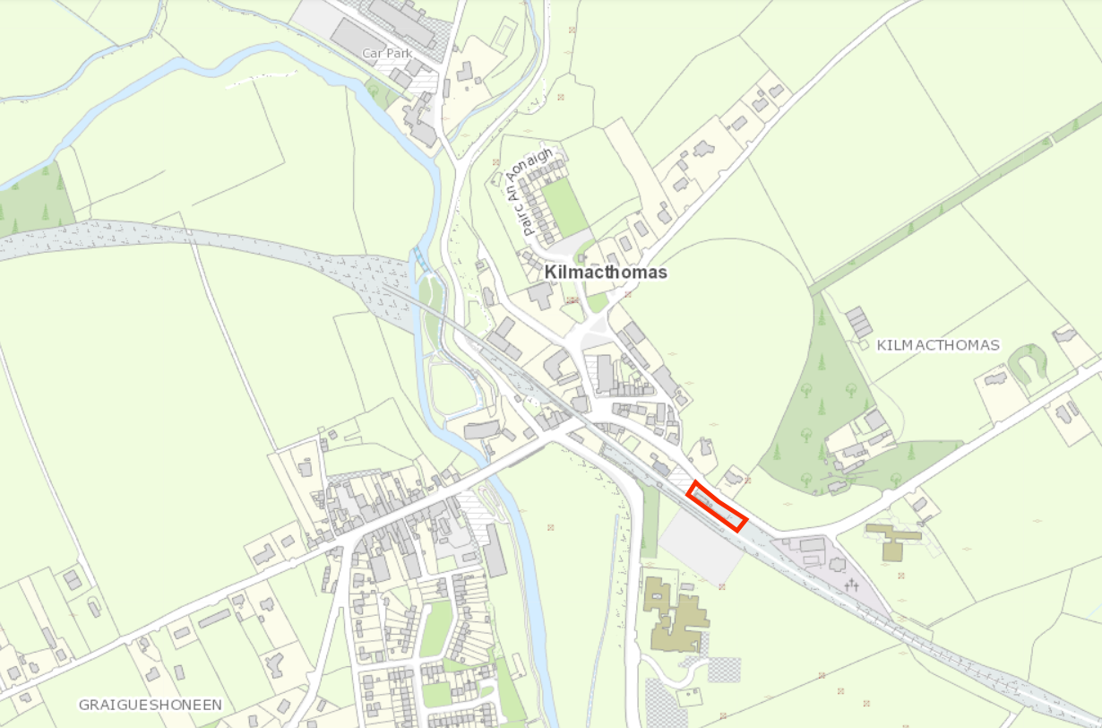

Fig 3.1 – Site Location Map

Site Appraisal

4.1 Site Context

The site is located in Kilmacthomas village within the Comeragh area of Waterford County, it encompasses an area of 0.03 ha and is occupied by the former Kilmacthomas Railway Station Building (Protected Structure). A public carpark adjoins the site to the west, the Waterford Greenway runs to the immediate south of the site.
The red-line site area is 280m² (0.03 ha).

4.2 Planning & Zoning
Within the current WCCC Plan 2022‐2028, the buildings within the site are zoned as follows:
- Kilmacthomas Settlement Boundary, WCCC Development Plan 2022 - 2028
- GZT Zone Category: RV - Rural Village - Protect and promote the character of the Rural Village and promote a vibrant community appropriate to available physical and community infrastructure. WCCC Development Plan 2022 - 2028

The proposal addresses a ‘Specific Development objective’ in Volume 3, Appendix No. 2 of the WCCC Development Plan 2022 – 2028 as follows:

- KMDO6/DO6 It is an objective of the Council to protect the elements of the streetscape of architectural or historical value, by the retention of the vernacular houses such as those on those on St Anne’s Terrace and on Main Street. Other features worthy of retention are rubblestone walls, freestanding water pumps, and elements of the former railway line including the Railway Station, post boxes and pillar boxes as identified the on NIAH survey.

Other policies of note that inform the proposed development include:
- Section 11.5 WCCC Development Plan 2022-2028:

BH 08 Reusing our Heritage Buildings
It is a policy of the Council to encourage sympathetic development or re-use of historic buildings to promote heritage let economic growth and regeneration works whilst not adversely detracting from the building or its setting. Any proposal shall respect features of the special architectural and historic character by appropriate design, materials, scale and setting.

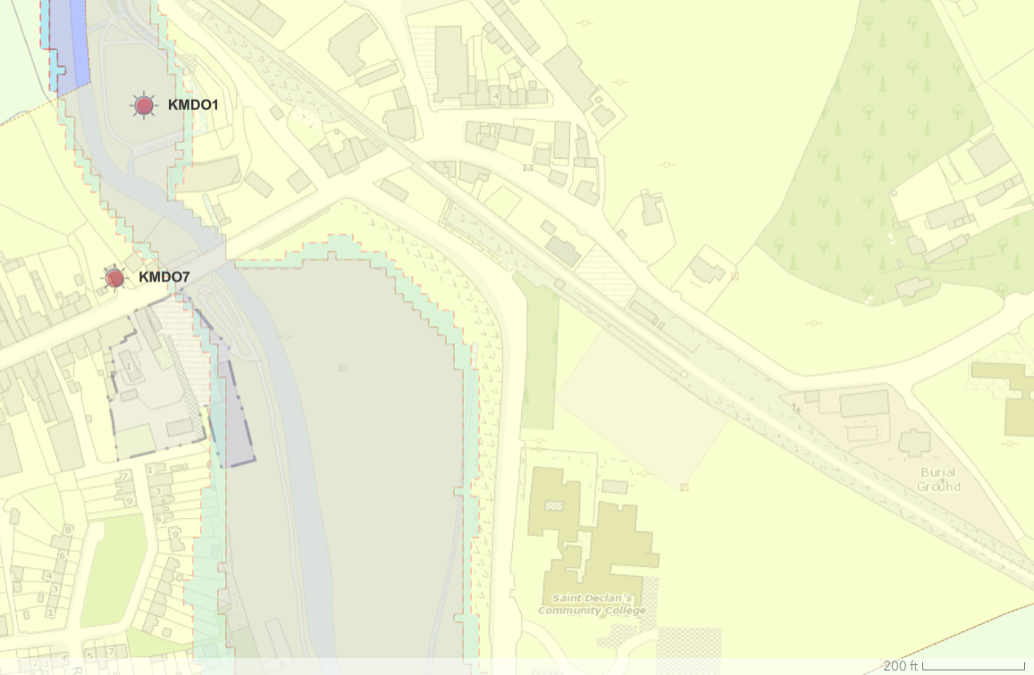
Fig 4.1 - Zoning Map

4.3 Services & Accessibility

4.3.1 Potable Water
Waterford City and County Council records show the site is fully serviced.

4.3.2 Foul Water & Storm Water
Records show foul water and combined sewers within the vicinity of the subject site.

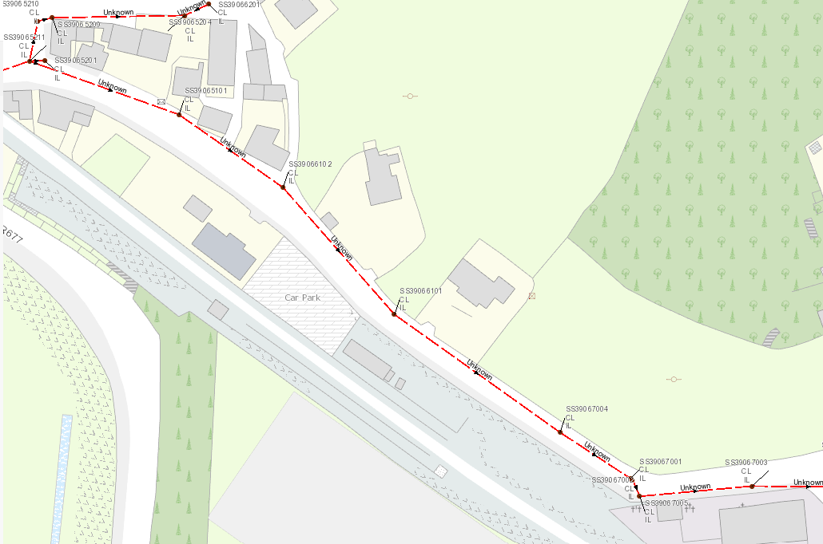

Fig 4.2 – Existing Sewer Network

4.3.3 Flood Risk
The subject site is not located within a flood zone according to the Waterford County Development Plan 2022-2028 and the OPW Flood Maps for the area.

4.3.4 Access
There is vehicular access to the site via the Rossmore Road. There is a designated car park for access to the Greenway and the proposed short term accommodation. Wheelchair accessible parking is also available. In addition, provision will be made for secure bicycle parking as part of the proposed development.

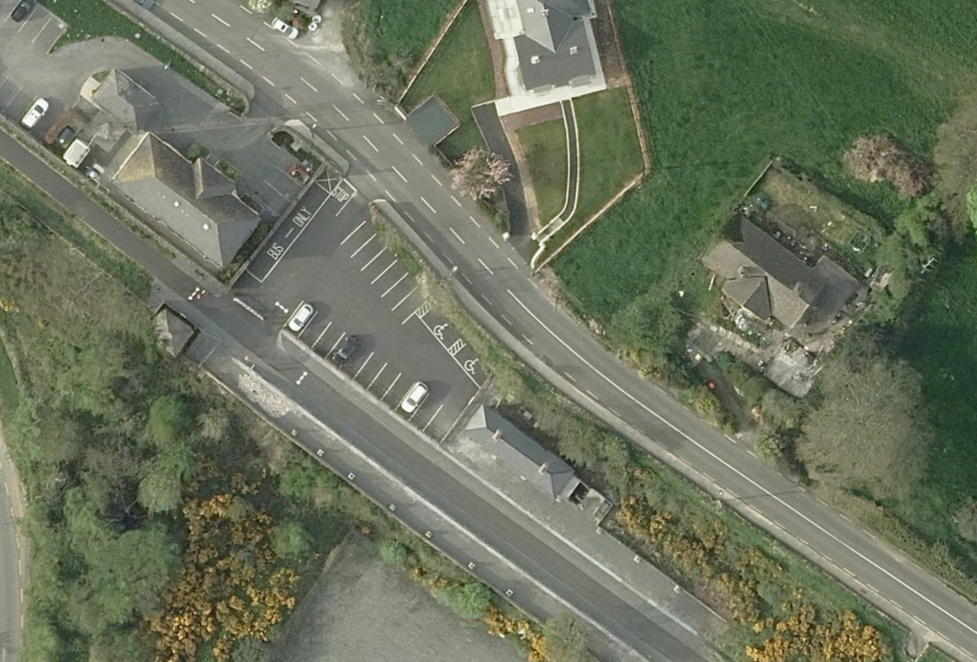

Fig 4.4 – Accessible Parking

4.3.6 Protected Structures and Archaeology

The Railway Station is a protected structure and appears in the on Waterford Councils list of registered protected structures:
WA750624, the building is described as follows: Detached five-bay single-storey railway station, opened 1878. Closed, 1982. Now derelict. Hipped slate roof with clay ridge tiles, rendered chimney stacks over red brick irregular bond construction, and remains of cast-iron rainwater goods.
Appraisal: An attractive, modest-scale railway station of simple, utilitarian form and appearance. Although now long disused, the railway station retains most of its original form and massing, while fragments of the original fittings and materials remain intact.
Archaeology – The site is on pre-disturbed ground above the level of the railway line.

Reference to a tank appears on the historic 25” Map, 1897-1913

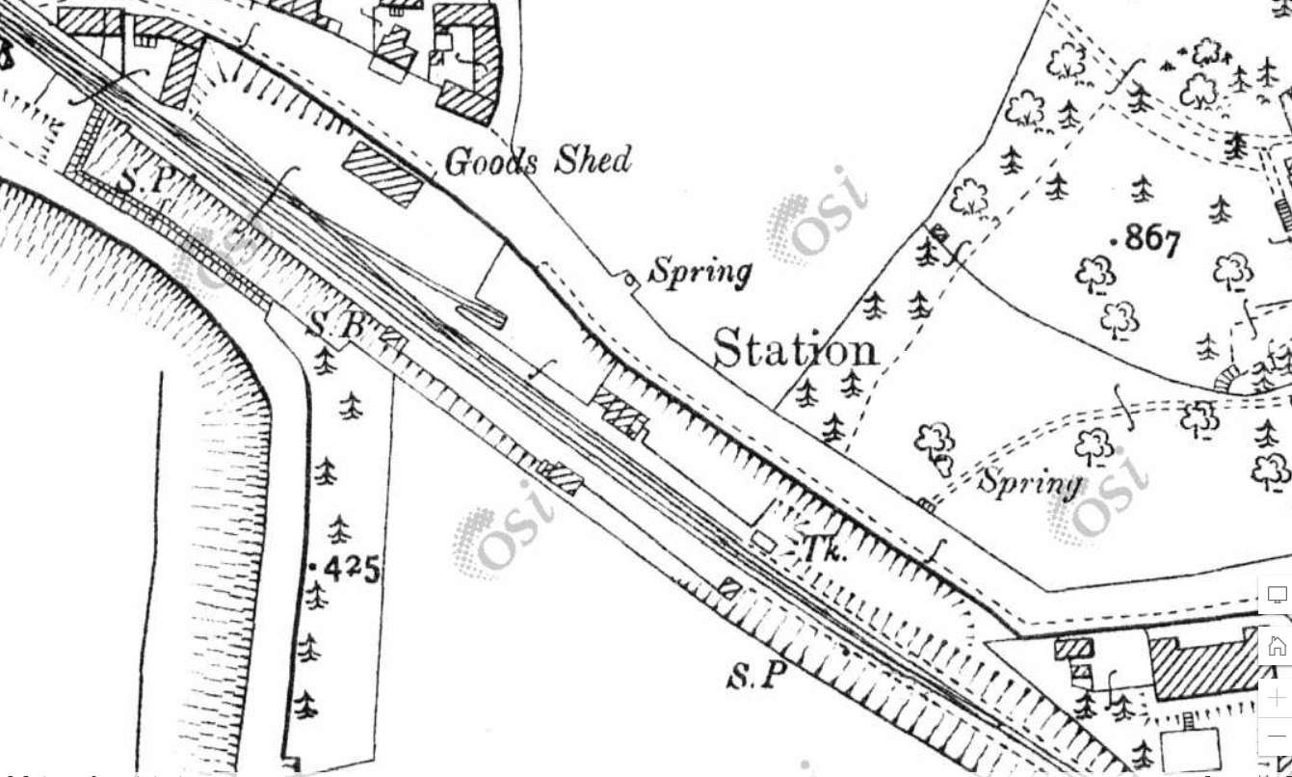

Fig 4.5 -Historic 25” Map, 1897-1913

4.5 Environmental Impact
Construction of the proposed alterations and introduction of three single storey units will have no negative impact on the existing facilities and only a very minor impact on the surrounding area.
A Screening Report for Appropriate Assessment and Environmental Impact Assessment Screening Report have been prepared and are included in support of this planning application – refer to appendix A for copies of both reports.
The Screening Report for Appropriate Assessment concludes that the project is not likely, alone or in-combination with other plans or projects, to have a significant effect on any European Sites.
In the Environmental Impact Assessment Screening Report, the proposal has been assessed as a sub-threshold Environmental Impact Assessment development and concludes that an Environmental Impact Assessment is not required.

4.6 Site Constraints and Abnormalities

The proposed development is on a brown field site with minimal constraints and abnormalities. The renovations and construction of the line huts and exhibition space will take place adjacent to the existing Greenway – a popular tourist attraction, for a number of weeks.

Prepared by:

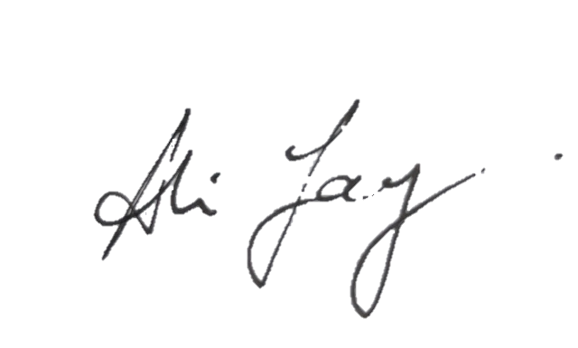

________________
Ali Jay
Technician,
Projects Team,
Economic Development, Waterford City & County Council

Supporting Documents

- Appendix A Screening Report for Appropriate Assessment and
Environmental Impact Assessment Screening Report

- Appendix B List of Drawings

- Architectural Heritage Impact Assessment

Appendix A – Environmental Screening Reports

  - Screening Report for Appropriate Assessment
and
  - Environmental Impact Assessment Screening Report

- Screening Report for Appropriate Assessment

Habitats Directive Project Screening Assessment

Table 1: Project Details

Development Consent Type | Local Authority Works- Part 8 Application
Development Location | Former Railway Station, Kilmacthomas
File Ref

Description of the project | Provision of tourist accommodation at former Railway Station

Table 2: Identification of Natura 2000 Sites (SACs and SPAs) which may be Impacted by the proposed development

Please answer the following five questions in order to determine whether there are any Natura 2000 sites which could potentially be impacted by the proposed development.

Impacts on SACs

1 | Impacts On Freshwater Habitats  Is the development within a Special Area of Conservation whose qualifying interests include freshwater habitats, or in the catchment of same?  Sites to consider: Blackwater River, Lower River Suir  Habitats to consider:  Rivers, Lakes and Lagoons | No
2 | Impacts On Wetland Habitats  Is the development within a Special Area of Conservation whose qualifying interests include wetland habitats, or within 1 km of same?  Sites to consider: Comeragh Mountains  Habitats to consider:  Bogs, Fens, Marshes and Wet Heaths. | No
3 | Impacts on Intertidal and Marine Habitats  Is the development located within a Special Area of Conservation whose qualifying interests include intertidal and/or marine habitats and species, or within the catchment of same.  Sites to consider: Tramore Dunes and Backstrand, River Suir (Tidal Section), River Blackwater (Tidal Section), Waterford Estuary  Habitats to consider:  Mudflats, Sandflats, Saltmarsh, Estuary; Shingle, Reefs, Sea Cliffs. | No
4 | Impacts On Woodlands , Grasslands and Dry Heaths  Is the development within a Special Area of Conservation whose qualifying habitats include woodlands or grasslands habitats, or within 200m of same.  Sites to consider: Glendine Wood Nire Valley Woods, Ardmore Head, Helvick Head  Habitats to consider:  Woodlands, Grasslands or Dunes. | No
5 | Impacts On Birds  Is the development within a Special Protection Area, or within 1 km of same.  Sites to consider: Tramore Backstrand, Dungarvan Bay, Blackwater Callows, Blackwater Estuary, Helvick Head –Ballyquin Coast, Mid Waterford Coast | No

Conclusion Table 2:

If the answer to all of these questions is No, significant impacts can be ruled out for Natura 2000 sites. No further assessment is required, proceed to the Habitats Directive Conclusion Statement.

If the answer to any of these questions is Yes lease refer to tables 3 and 4 below.

Table 3: Determination of Possible Impacts On Natura 2000 Sites.
Where it has been identified that there is a Natura 2000 site within the potential impact zone of the proposed development, it is necessary to try to determine the nature of the possible impacts. Please answer the following questions as appropriate.

1 | Impacts on designated freshwater habitats (rivers, lakes streams and lagoons).  Sites to consider: Blackwater River, Lower River Suir  Please answer the following if the answer to question 1 in table 2 was yes.  Does the development involve any of the following:
 | Works inside the boundary of designated site
1.1 | All works within the boundary of any SAC whose qualifying features include freshwater habitats/species, excluding small extensions/alterations to existing buildings. | No
 | Works outside the boundary of designated site
1.2 | Discharge to surfacewater or groundwater within the boundary of an SAC whose qualifying features include freshwater habitats/species.
1.3 | Abstraction from surfacewater or groundwater within 1km of the boundary of an SAC whose qualifying features include freshwater habitats or species.
1.4 | Removal of topsoil within 100m of the boundary of an SAC, whose qualifying features include freshwater habitats/species.
1.5 | Infilling or raising of ground levels within 100m the boundary of any SAC whose qualifying features include freshwater habitats/species.
1.6 | Construction of drainage ditches within 1km of the boundary of an SAC whose qualifying features include freshwater habitats/species.
1.7 | Installation of waste water treatment systems; percolation areas; septic tanks within 100 m of the boundary of an SAC site whose qualifying features include freshwater habitats/species.
1.8 | Construction within a floodplain of EU designated watercourse whose qualifying features include freshwater habitats/species.
1.9 | Crossing or culverting of rivers or streams within 1km of the boundary of any SAC whose qualifying features include freshwater habitats.
1.10 | Storage of chemicals hydrocarbons or organic wastes within 100 m of the boundary of an SAC whose qualifying features include freshwater habitats/species.
1.11 | Development of a large scale, within catchment of an EU designated watercourse or waterbody, which involves the production of an EIS.
1.12 | Development or expansion of quarries within catchment of an EU designated watercourse or waterbody.
1.13 | Development or expansion of windfarms within catchment of an EU designated watercourse or waterbody.
1.14 | Development of pumped hydro electric stations within catchment of an EU designated watercourse or waterbody.
2 | Impacts On Wetland Habitats  Is the development within a Special Area of Conservation whose qualifying interests include wetland habitats, or within 1 km of same?  Sites to consider: Comeragh Mountains  Habitats to consider:  Bogs, Fens, Marshes and Wet Heaths.  Please answer the following if the answer to question 2 in table 2 was yes.
 | Works inside the boundary of designated site
2.1 | All works within the boundary of an SAC whose qualifying features include heath, marsh, fen or bog, excluding small extensions/alterations to existing buildings. | No
 | Works outside the boundary of designated site
2.2 | Construction of roads or other infrastructure on peat habitats within 1km of any SAC whose qualifying features include heath, marsh, fen or bog.
2.3 | Development of a large scale within 1km of any SAC, whose qualifying features include heath, marsh, fen or bog, which involves the production of an EIS.
3 | Impacts on Intertidal and Marine Habitats  Is the development located within a Special Area of Conservation whose qualifying interests include intertidal and/or marine habitats and species, or within the catchment of same.  Sites to consider: Tramore Dunes and Backstrand, River Suir (Tidal Section), River Blackwater (Tidal Section), Waterford Estuary  Please answer the following if the answer to question 1 in table 3 was yes.
 | Works inside the boundary of designated site
3.1 | All works within the boundary of any SAC whose qualifying features include intertidal or marine habitats, excluding small extensions/alterations to existing buildings. | No
 | Works outside the boundary of designated site
3.2 | Coastal protection works within 5km of any SAC whose qualifying features include intertidal or marine habitats.
3.3 | Development of piers, slipways, marinas, pontoons or any other infrastructure within 5km of any SAC whose qualifying features include intertidal or marine habitats.
3.4 | Dredging within 5km of any SAC whose qualifying features include intertidal or marine habitats.
3.5 | Works within 1km of any SAC whose qualifying features include intertidal or marine habitats, which will result in discharges to rivers or streams directly connected to the designated site.
3.6 | Infilling of coastal habitats within 500m of any SAC whose qualifying features include intertidal or marine habitats.
3.7 | Removal of topsoil or infilling of terrestrial habitats within 100m of any SAC whose qualifying features include intertidal or marine habitats.
3.8 | Development of a large scale within 1km of any SAC whose qualifying features include intertidal or marine habitats, which involves the production of an EIS.
4 | Impacts on other designated woodlands and grasslands (woodland, upland grassland, lowland grassland, coastal grassland including dunes).  Sites to consider: Glendine Wood Nire Valley Woods, Ardmore Head, Helvick Head  Please answer the following if the answer to question 4 in table 2 was yes.  Does the development involve any of the following:
 | Works inside the boundary of designated site
4.1 | All works within the boundary of any SAC whose qualifying interests include woodland or grassland habitat types excluding small extensions/alterations to existing buildings. | No
 | Works outside the boundary of designated site
4.2 | Development within 200m of any SAC whose qualifying interests include woodland or grassland habitat types.
4.3 | Development of a large scale within 1km of any SAC, whose qualifying interests include woodland or grassland habitat types, which involves the production of an EIS.
5 | Impacts on birds in SPAs  Sites to consider: Tramore Backstrand, Dungarvan Bay, Blackwater Callows, Blackwater Estuary, Helvick Head –Ballyquin Coast, Mid Waterford Coast  Please answer the following if the answer to question 5 in table 2 was yes.  Does the development involve any of the following:
 | Works inside the boundary of designated site
5.1 | All works within the boundary of any SPA excluding small extensions/alterations to existing buildings. | No
 | Works outside the boundary of designated site
5.2 | Erection of wind turbines within 1km of any SPA.
5.3 | All construction works within 100m of any SPA.
5.4 | Infilling of coastal habitats within 500m of intertidal SPA.
5.5 | Works within 1km of coastal/wetland SPAs which will result in discharges to rivers or streams that are directly connected to designated sites.
5.6 | Development of cycleways or walking routes within 100m of SPAs.
5.7 | Construction works on feeding areas adjacent to SPAs

Conclusion Table 3: If the answer to all of the above is no or n/a, significant impacts on Natura 2000 sites can be ruled out. No further assessment is required, proceed to the Screening Conclusion Statement. If the answer to any question in table 3 is yes, you may require further information, unless you are satisfied that the project proponents have incorporated adequate mitigation into their design to avoid impacts on the Natura 2000 site (e.g. water pollution protection measures). Such information should be provided in the form of a Natura Impact Statement which should address the particular issues of concern as identified through the above.

Table 4: Consideration of Potential Impacts on Protected Species
Many of our Special Areas of Conservation are designated for species as well as for habitats. These are listed below, alongside the sites for which they are designated. Included is a short list of the types of activities which could have an impact on these species. Please tick if you are concerned that the proposed development could have an impact on these species.

Species | Relevant Sites | Activites which could have impacts on species | Possible Impacts Identified? Y/N
Otter | Lower River Suir  River Blackwater  Waterford Estuary | Activities that interfere with river banks. | No
Bats (all species outside designated sites) | Blackwater River, Lower River Suir, Waterford Estuary  Glendine Wood, Lismore Woods Nire Valley Woods  Along with above, in general all sites with any of the following; woods, mature treelines and hedgerows, old buildings and bridges | Activities that result in loss of woodland or hedgerow habitat or causes disturbance to roost sites. Renovations of old buildings; Repointing of old bridges. | No
Salmon | Lower River Suir  River Blackwater  Waterford Estuary | Activities that interfere with water quality, levels or the river bed; | No
River Lamprey | Lower River Suir  River Blackwater  Waterford Estuary | Activities that interfere with water quality, levels or the river bed; | No
Brook Lamprey | Lower River Suir  River Blackwater  Waterford Estuary | Activities that interfere with water quality, levels or the river bed; | No
Sea Lamprey | Lower River Suir  River Blackwater  Waterford Estuary | Activities that interfere with water quality or the river bed – estuarine areas; | No
Twaite Shad  Allis Shad | Lower River Suir  River Blackwater  Waterford Estuary | Activities that interfere with water quality or the river bed – estuarine areas; | No
White-clawed Crayfish | Lower River Suir  River Blackwater  Waterford Estuary | Activities that interfere with water quality or the river bed; | No
Freshwater Pearl Mussel | Lower River Suir  River Clodiagh  River Lickey  River Blackwater | Activities that interfere with water quality, levels or the river bed ; | No
Whorled Snail  Vertigo moulinsiana | River Blackwater | Activities that result in loss of fen, marsh or wet grassland habitat within or close to the SAC. | No
Killarney Fern | Glendine Wood  Lismore Woods (River Blackwater) | Woodland clearance or other activities resulting in loss or disturbance to woodland habitat within the relevant SACs. | No

Conclusion Table 4: If the answer to all of the above is no, significant impacts on species can be ruled out. If the answer to any of the above is yes, then further information is likely to be required in relation to potential for impact on that particular species. Where potential impacts on the above listed species are within designated sites, then further information should be sought in the form of a Natura Impact Statement. Where impacts are outside designated sites, then a species specific survey should be requested.

Habitats Directive Screening Conclusion Statement

Development Type |  | Local Authority Works - Part 8 Development
Development Location |  | Kilmacthomas
Natura 2000 sites within impact zone |  | 7km south east of the Comeragh Mountains SAC.
Planning File Ref

Description of the project

To provide short stay tourism accommodation in the former railway station at Kilmacthomas on the Waterford Greenway.
Describe how the project or plan (alone or in combination) could affect Natura 2000 site(s)

The works are within a self contained site with no physical or hydrological connectivity with Natura 2000 sites.
If there are potential negative impacts, explain whether you consider if these are likely to be significant, and if not, why not.
No physical or hydrological connectivity with Natura 2000 sites. No potential for significant effects on the conservation objectives of the Natura 2000 Network.
Conclusion of assessment
The proposed works will not cause significant effects to the conservation objectives of Natura 2000 Network including Comeragh Mountains SAC.
Documentation reviewed for making of this statement.

WCCC Internal GIS

Completed By | Bernadette Guest
Date | 26th February 2024

- Environmental Impact Assessment Screening Report

1.Introduction
The EIA Directive 85/337/EEC, as amended aims to determine the likely significant effects of a project on the environment. EIA Screening determines whether an EIA is required for a specified project. Projects requiring mandatory EIA are listed in Schedule 5 of the Planning and Development Regulations 2001 , as amended. In the case of development which is under these thresholds , planning authorities are required under Article 103 of the 2001 Regulations, (as amended) to request an EIAR where it considers that the proposed development is likely to have a significant effect on the environment.
Under Schedule 5 of the Planning and Development Regulations 2001 (as amended), the proposed development is sub-threshold for EIA. The proposed development is being screened as per Schedule 7 of the regulations to determine if there is likely to be significant effects on the environment. Screening involves appraisal of impacts from the proposed development according to three main criteria:-
- Characteristics of the proposed development
- Location of proposed development
- Characteristics of potential impacts.
Schedule 6 of the Planning and Development Regulations, 2001 (as amended), outlines the aspects of the environment likely to be significantly affected by a proposed development. These are: human beings, flora and fauna, soil and geology, water, air& climate, landscape, material assets, cultural heritage and the inter-relationships between the range of environmental criteria. EIA screening involves assessment of these criteria to determine if the proposed development is likely to significantly affect the environment.

2. Screening Assessment

Table 1. Characteristics of proposed development
Is the size and design of the proposed works significant ? | No the site is approximately 100m² .
Use of natural resources in particular land, soil, water and biodiversity ? | Proposed works involve provision of tourism accommodation at the renovated and former Kilmacthomas Railway Station adjacent to Waterford Greenway.
Will the works produce waste ? | Construction waste during scheme works.
Will the works create a significant amount of pollution or nuisance ? | No
Risk of major accidents and/or disasters relevant to the project including those caused by Climate Change in accordance with scientific knowledge ? | Works will be governed by a health and safety statement. Providing best practice is followed the risk of accidents which are significant in scale is considered low.
Risks to human health (water contamination , air pollution) | Works will be governed by a health and safety statement. Providing best practice is followed the risk to human health is considered low.
Potential for cumulative impacts with other existing and/or approved projects? | Low risk of significant effects
Potential for combination of above factors to have significant effects | Low risk of significant effects

Table 2. Location of Proposed Development
Environmental sensitivity of project in relation to existing and approved land use. | The building is a protected structure within an Architectural Conservation Area.
Relative abundance, availability, quality and regenerative capacity of natural resources (including soil, land, water and biodiversity) in the area and its underground. | Proposed works involve upgrades to a protected structure within an Architectural Conservation Area.
Absorption capacity of the natural environment including wetlands, riparian areas, river mouths, coastal zones and the marine environment, mountain and forest area. | The self contained nature of the works will avoid impacts on the natural environment.
Potential of works to impact directly or indirectly on sites designated for nature conservation (NHA/SAC/SPA) | Due to distance of site from the Mid-Waterford Coast SPA and Comeragh Mountains SAC there is no potential for significant effects on the conservation objectives of the SPA. AA screening has been carried out and has concluded no potential for significant effects.
Potential for impacts directly or indirectly on Habitats or Species listed on Annex 1 of the Habitats Directive | AA screening has been carried out and has concluded no potential for significant effects.
Potential for impacts directly or indirectly on Species listed on Annex IV of the Habitats Directive | No
Potential for impacts on breeding places of any species protected under the Wildlife Act ? | No
Potential to impact directly or indirectly on any listed ACA in the City Development Plan ? | Proposed works involve upgrades to a protected structure within an Architectural Conservation Area.
Potential to impact directly or indirectly on any protected structure or recorded monuments and places of Archaeological Interest | No recorded monuments will be impacted by the works.
Potential to impact directly or indirectly on  Listed or scenic views or protected landscape in the County Development Plan ? | The site is not within a scenic view or protected landscape in the City and County Development Plan 2022-2028.
Potential to impact on areas in which there has already been a failure to meet the environmental quality standards and relevant to the project, or in which it is considered that there is such a failure. | None arising.
Potential to impact on densely populated areas. | The site is located in a rural area with low population density.

Table 3. Characteristics of Potential Impacts
Human Beings | Provision of tourism accommodation will be a positive effect for the local economy.
Flora and Fauna | AA screening has been carried out and has concluded no potential for significant effects.
Soils and Geology | No protected geological heritage sites will be impacted.
Water | Foul and Grey water will discharge to the existing drainage network.
Air & Climate | The proposed development is located in a rural area and will not negatively impact air quality.
Noise & Vibration | Small scale and temporary during construction works.
Landscape | The proposed development is located in a rural area and will not negatively impact on the existing landscape.
Material Assets | Works will be subject to and regulated by a waste management plan.
Cultural Heritage | An Architectural Heritage Impact Assessment is required.
Interaction of Foregoing | The main effect identified is works involve upgrades to a protected structure within an Architectural Conservation Area.

Table 4. Discussion of Potential Impacts
Will a large geographical area be impacted as a result of the proposed works ? | No, self contained site of a small scale.
Will a large population be impacted as a result of the proposed works ? | No, site is in a low population area but provision of tourism accommodation will be a positive effect for the local economy.
Are any trans-frontier impacts likely to arise from proposed works? | No
Is the magnitude of impacts associated with the proposed works considered significant ? | No short term and temporary in nature
Is the intensity and complexity of impacts associated with the proposed works considered significant ? | No
Is there a high probability that the effects will occur ? | No significant effects arising.
Will the effects continue for a long time ? | No significant effects arising.
Will the effects be permanent rather than temporary ? | No significant effects arising.
Will the impacts be irreversible? | No significant effects arising.
Will it be difficult to avoid, or reduce or repair or compensate for the effects ? | No significant effects arising.

3..Conclusion
The DoEHLG Guidance Document “Environmental Impact Assessment (EIA) Guidance for Consent Authorities regarding Sub-Threshold Development” notes that “The greater the number of different aspects of the environment which are likely to be affected and the greater the links between the effects, the more likely it is that an EIS should be carried out. Where complexity of impacts is deemed to apply in the case of a specific sub-threshold development proposal, there should be a predisposition towards the preparation of an EIS”.
In consideration of the above involving appraisal of characteristics and location of proposed development and characteristics of potential impacts it is concluded that due to the small scale nature of the works which involve a previously renovated structure that an EIAR is not required for the proposed development. The proposal shall be supported by an Architectural Heritage Impact Assessment.

Appendix B – List of Drawings

The drawings that accompany this Part 8 report are as listed below:

Ordinance Survey Sit Location map- 1:1000

Drawing 1 -Site Layout 1:1000
Drawing 2- Overall scheme 1:500
Drawing 3- Renovation of Rail Station 1:100
Drawing 4- Proposed Line Huts 1:50
Drawing 5- Proposed Exhibition space / Model display

