Proposed redevelopment of the Skate Park at The Prom, Tramore, Co. Waterford
Planning & Development Act 2000 amended
Planning & Development Regulations 2001 as amended Part VIII, Revised 2021
Notification to Commence Part VIII Process

Objective
Waterford City & County Council is proposing to extend and redevelop the existing Skate Park at the Promenade (L4345), Tramore, Co. Waterford.

The current Skate Park comprises of a number of demountable features and was constructed circa 20 years ago. Much of the equipment is constructed from steel, fibreglass and timber, has deteriorated in recent years and is now beyond its service life.

It is proposed to construct a new Skate Park on the site using concrete forms that will provide a high quality redevelopment of the Skate Park, add to the publicly accessible outdoor recreational facilities in Tramore and significantly improve the visual aesthetics on the Lower Prom area.

Site Location Map
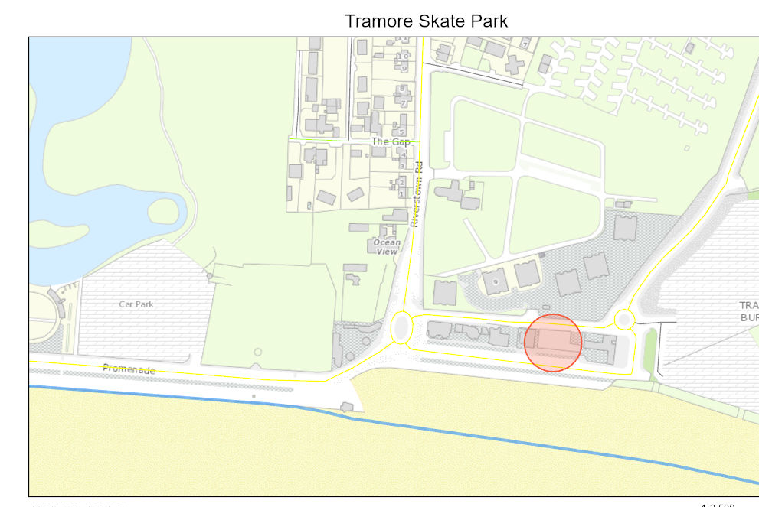

Site Appraisal

- The site is located at The Promenade, Tramore bounded by the public toilet block to the eastern side and the National Lifeguard Training centre to the west.
- The site is currently in use partly as Skate Park and partly public footpath
- The site area is approximately 726 square metres
- Site designation: Waterford City & County Council Development Plan 2022 – 2028
  - Zoning – TM to provide for Tourism use
  - The site lies within the Tramore Settlement Boundary
  - The site lies with the OPW NCFHM High-End future 1 in 1000 year Flood Extend
- Planning history – there is no prior planning history for this site

Design Concept

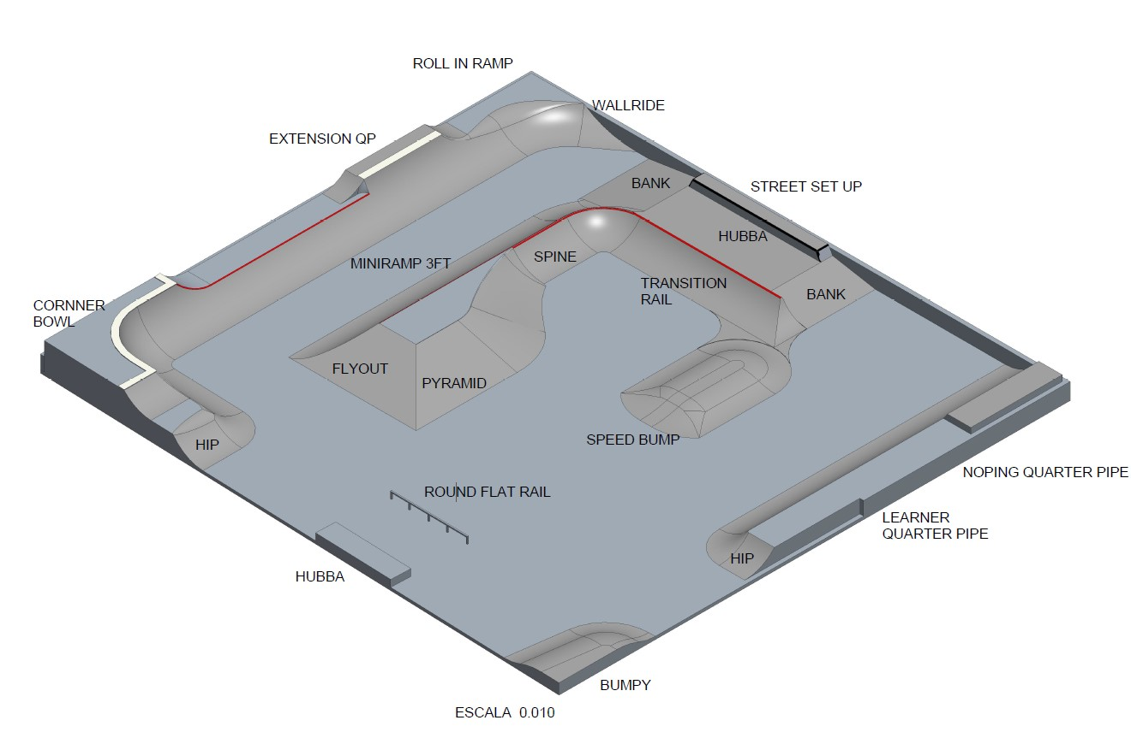

Brief

To redevelop and extend the Skate Park at The Prom, Tramore.

The existing Skate Park was constructed circa 20 years ago and much of the equipment has deteriorated and several elements have been removed due to safety concerns.

It is proposed to extend the area of the Skate Park to include the public footpath to the southern boundary of the site and to construct a new 2.4m wide footpath. This will necessitate the removal of circa 6 no. car parking spaces.

The proposed new Skate Park will be formed in concrete, will combine elements of ramps, bowls and street plaza features to be constructed in concrete and has been designed with the specific needs of both novice and experienced skateboarders in mind.

The local Skateboarders have been consulted in the creation of the preliminary design and it is proposed to engage a specialist company to undertake the detailed design and construction of the Park.

The proposed Skate Park will be very similar in size and concept to the recently opened facility at Fairlane, Dungarvan.

Scheme Delivery

It is intended to procure the delivery of this scheme by means of a design / build contract in accordance with national procurement policy.

Project approval and oversight will be managed and delivered by WC&CC staff.

Estimated Project time-line

- Part 8 Planning public consultation to commence February 2024
- Part 8 to revert to Metropolitan District Council for decision March 2024
- Procurement of Design / Build Contract March 2024
- Construction May – July 2024

Fergus Galvin
Director Roads, Water & Environmental Services
Waterford City & County Council
January 2024

