Planning Report

Proposed Development:

Provision of new skate park at The Promenade, Tramore, Co. Waterford

The majority of the subject site is zoned Tourism with the objective to “Provide for tourism uses” in the Waterford City & County Development Plan 2022-2028 – this area is occupied by an existing skate park. A portion of the subject site to the south is not zoned for any specific use and forms part of the public car parking area and footpath associated with the Prom area of Tramore.

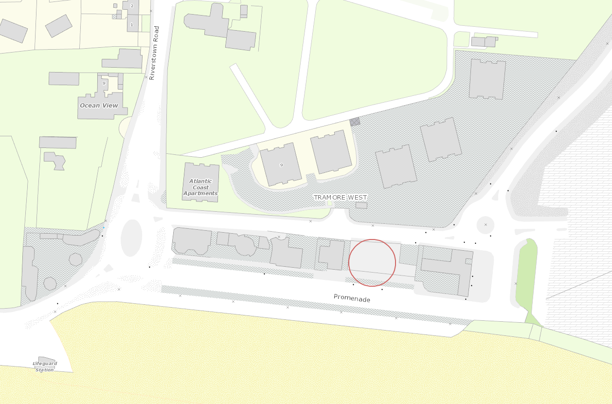

The proposed development is to provide for a new skate park to replace the existing skate park at the site. It is also proposed to utilise an area that currently provides public car parking and footpath at The Prom area and incorporate same into the site of the proposed new skate park. The proposed development is considered compatible with the zoning objectives for the site.

The proximity of the site to the Tramore Backstrand and associated protected sites is noted and in this regard the Heritage Officer has provided comments indicating that there are no concerns regarding impact on said protected sites. An Appropriate Assessment Screening Report is attached to this report.

Development such as that currently proposed would be in accordance with the broad policy objectives of the Waterford City & County Development Plan 2022-2028 subject to compliance with the objectives and standards as set out in:

- Volume 1 of the Waterford City & County Development Plan 2022-2028 – Written Statement.
- Volume 2 of the Waterford City & County Development Plan 2022-2028 - Development Management Standards

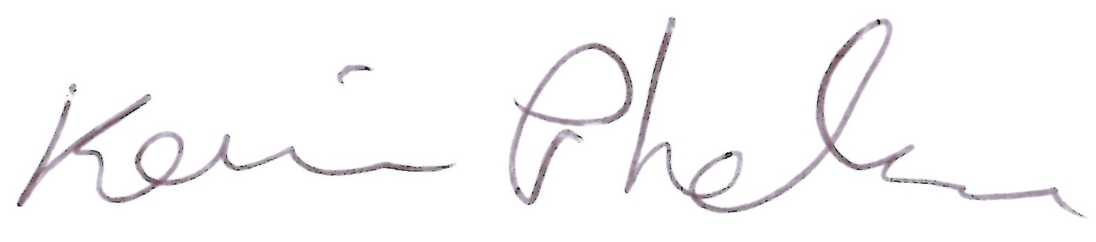
___________________________ Date:__16/01/2024_______
Kevin Phelan
Executive Planner
____________________________ Date:__________________
Hazel O’Shea
Senior Executive Planner

Environmental Impact Assessment
The proposed development is not for a type of development included for under Schedule 5 of the Planning and Development Regulations 2001, as amended. Based on the information submitted with the application, Waterford City and County Council has considered the nature, size and location of the proposed development in the context of the criteria set out in Schedule 7 to the 2001 Regulations and is satisfied that EIA is not required.

Habitats Directive Project Screening Assessment

Table 1: Project Details
Application | Details
Development Consent Type | Part 8
Development Location | The Promenade, Tramore, Co. Waterford
Description of the project | Provision of new skate park at The Promenade, Tramore, Co. Waterford

Table 2: Identification of Natura 2000 Sites (SACs and SPAs) which may be impacted by the proposed development
Please answer the following five questions in order to determine whether there are any Natura 2000 sites which could potentially be impacted by the proposed development.
Number | Question | Response
1 | Impacts On Freshwater Habitats Is the development within a Special Area of Conservation whose qualifying interests include freshwater habitats, or in the catchment of same? Sites to consider: Blackwater River, Lower River Suir Habitats to consider: Rivers, Lakes and Lagoons. | N/A
2 | Impacts On Wetland Habitats Is the development within a Special Area of Conservation whose qualifying interests include wetland habitats, or within 1 km of same? Sites to consider: Comeragh Mountains Habitats to consider: Bogs, Fens, Marshes and Wet Heaths. | N/A
3 | Impacts on Intertidal and Marine Habitats Is the development located within a Special Area of Conservation whose qualifying interests include intertidal and/or marine habitats and species, or within the catchment of same. Sites to consider: Tramore Dunes and Backstrand, River Suir (Tidal Section as far as Carrick on Suir ), River Blackwater (Tidal Section as far as Cappoquin), Waterford Estuary Habitats to consider: Mudflats, Sandflats, Saltmarsh, Estuary; Shingle, Reefs, Sea Cliffs. | No
4 | Impacts On Woodlands , Grasslands and Dry Heaths Is the development within a Special Area of Conservation whose qualifying habitats include woodlands or grasslands habitats, or within 200m of same. Sites to consider: Glendine Wood Nire Valley Woods, Ardmore Head, Helvick Head Habitats to consider: Woodlands, Grasslands or Dunes. | N/A
5 | Impacts On Birds Is the development within a Special Protection Area, or within 1 km of same. Sites to consider: Tramore Backstrand, Dungarvan Bay, Blackwater Callows, Blackwater Estuary, Helvick Head –Ballyquin Coast, Mid Waterford Coast | No
Conclusion Table 2:
If the answer to all of these questions is No, significant impacts can be ruled out for Natura 2000 sites. No further assessment is required, proceed to the Habitats Directive Conclusion Statement. If the answer to any of these questions is Yes lease refer to tables 3 and 4 below.

Table 3: Determination of Possible Impacts On Natura 2000 Sites.
Where it has been identified that there is a Natura 2000 site within the potential impact zone of the proposed development, it is necessary to try to determine the nature of the possible impacts. Please answer the following questions as appropriate.
Number | Question | Response
1 | Impacts on designated freshwater habitats (rivers, lakes streams and lagoons). Sites to consider: Blackwater River, Lower River Suir.
 | Please answer the following if the answer to question 1 in table 2 was yes. Does the development involve any of the following: | N/A
 | Works inside the boundary of designated site
1.1 | All works within the boundary of any SAC whose qualifying features include freshwater habitats/species, excluding small extensions/alterations to existing buildings. | N/A
 | Works outside the boundary of designated site
1.2 | Discharge to surfacewater or groundwater within the boundary of an SAC whose qualifying features include freshwater habitats/species. | N/A
1.3 | Abstraction from surfacewater or groundwater within 1km of the boundary of an SAC whose qualifying features include freshwater habitats or species. | N/A
1.4 | Removal of topsoil within 100m of the boundary of an SAC, whose qualifying features include freshwater habitats/species. | N/A
1.5 | Infilling or raising of ground levels within 100m the boundary of any SAC whose qualifying features include freshwater habitats/species. | N/A
1.6 | Construction of drainage ditches within 1km of the boundary of an SAC whose qualifying features include freshwater habitats/species. | N/A
1.7 | Installation of waste water treatment systems; percolation areas; septic tanks within 100 m of the boundary of an SAC site whose qualifying features include freshwater habitats/species. | N/A
1.8 | Construction within a floodplain of EU designated watercourse whose qualifying features include freshwater habitats/species. | N/A
1.9 | Crossing or culverting of rivers or streams within 1km of the boundary of any SAC whose qualifying features include freshwater habitats. | N/A
1.1 | Storage of chemicals hydrocarbons or organic wastes within 100 m of the boundary of an SAC whose qualifying features include freshwater habitats/species. | N/A
1.11 | Development of a large scale, within catchment of an EU designated watercourse or waterbody, which involves the production of an EIS. | N/A
1.12 | Development or expansion of quarries within catchment of an EU designated watercourse or waterbody.. | N/A
1.13 | Development or expansion of windfarms within catchment of an EU designated watercourse or waterbody. | N/A
1.14 | Development of pumped hydro electric stations within catchment of an EU designated watercourse or waterbody. | N/A
3 | Impacts on Intertidal and Marine Habitats -Is the development located within a Special Area of Conservation whose qualifying interests include intertidal and/or marine habitats and species, or within the catchment of same.Sites to consider: Tramore Dunes and Backstrand, River Suir (Tidal Section), River Blackwater (Tidal Section), Waterford Estuary.
 | Please answer the following if the answer to question 1 in table 3 was yes. | N/A
 | Works inside the boundary of designated site
3.1 | All works within the boundary of any SAC whose qualifying features include intertidal or marine habitats, excluding small extensions/alterations to existing buildings. | N/A
 | Works outside the boundary of designated site | N/A
3.2 | Coastal protection works within 5km of any SAC whose qualifying features include intertidal or marine habitats. | N/A
3.3 | Development of piers, slipways, marinas, pontoons or any other infrastructure within 5km of any SAC whose qualifying features include intertidal or marine habitats. | N/A
3.4 | Dredging within 5km of any SAC whose qualifying features include intertidal or marine habitats. | N/A
3.5 | Works within 1km of any SAC whose qualifying features include intertidal or marine habitats, which will result in discharges to rivers or streams directly connected to the designated site. | N/A
3.6 | Infilling of coastal habitats within 500m of any SAC whose qualifying features include intertidal or marine habitats. | N/A
3.7 | Removal of topsoil or infilling of terrestrial habitats within 100m of any SAC whose qualifying features include intertidal or marine habitats. | N/A
3.8 | Development of a large scale within 1km of any SAC whose qualifying features include intertidal or marine habitats, which involves the production of an EIS. | N/A
Conclusion Table 3:
If the answer to all of the above is no or n/a, significant impacts on Natura 2000 sites can be ruled out. No further assessment is required, proceed to the Screening Conclusion Statement.

Habitats Directive Screening Conclusion Statement
Question | Answer
Development Type | Part 8
Development Location | The Promenade, Tramore, Co. Waterford
Natura 2000 sites within impact zone
Description of the project | Provision of new skate park
Describe how the project or plan (alone or in combination) could affect Natura 2000 site(s).
If there are potential negative impacts, explain whether you consider if these are likely to be significant, and if not, why not.
Conclusion of assessment | Having regard to the location of the subject site and to the nature of the proposed development, and the intervening distance with the identified Natura 2000 Sites, I consider that no appropriate assessment issues arise in this case. In my opinion the proposed development either individually or in combination with other plans or projects, would not be likely to have a significant effect on a Natura 2000 Site.
Documentation reviewed for making of this statement.
Completed By | Kevin Phelan, Executive Planner
Date | 16th January 2024

